Maximizing Employee Engagement
Instructor Guide
This page is intentionally left blank.
Front Matter
United States
Office of Personnel Management
Executive Services
Senior Executive Service & Performance Management
1900 E Street, NW
Washington, DC 20415

This page left intentionally blank.

Table of Contents
Purpose of This Guide 1
Maximizing Employee Engagement WBT Recommendation 1
Recommended General Course Guidelines 1
Instructor Expertise 1
Room Requirements 2
Using a Parking Lot 2
Administrative Details 2
Structure and Content of Guides 3
Instructor Guide (IG) 3
IG Sections 3
Voice and Spoken Text 3
Icons Used in the IG 3
Participant Guide (PG) 4
Suggested Course Agenda 4
Course Activities 5
Equipment and Supplies 7
Presentation Instructions 7
Before the ILT Session 7
Morning of the ILT Session 8
During the ILT Session 8
After the ILT Session 9
Section 1: PowerPoint Slides and Instructor Notes 11
Introduction 13
Lesson Overview 13
Course Overview 15
Factors that Influence Engagement 22
Lesson Overview 22
Overview of Engagement 24
You and Your Employees’ Engagement 33
Matching Motivators to Individuals 43
Lesson Overview 43
Job Characteristics 46
Leadership Styles 55
Barriers to Engagement 61
Lesson Overview 61
Interpersonal Barriers 63
Organizational Barriers 72
Develop an Action Plan 78
Lesson Overview 78
Action Plan 80
Conclusion 84
Lesson Overview 84
Section 2: Activities Materials 91
Activity: Factors that Influence Your Engagement 93
Activity: Challenges that Influence Your Employees’ Engagement 94
Activity: Different Strokes for Different Folks 95
PART 1 95
PART 2 96
Activity: Matching your Leadership Style to the Situation 97
Goleman’s Six Leadership Styles 97
Activity: Matching your Leadership Style to the Situation, continued 98
Activity: Matching your Leadership Style to the Situation, continued 100
Activity: Your Interpersonal Barriers 101
Activity: Role Play 102
Scenario 102
Task 102
Role Play Action Plan 103
Reflection Activity 103
Activity: Develop Your Action Plan 111
Your Action Plan 112
Section 3: Job Aids 113
Job Aid: Debunking Myths about Employee Engagement 115
Job Aid: Ways to Create a Culture of Engagement 117
Job Aid: Fast Track to Lowering Engagement 119
Job Aid: Other Government Agencies’ Strategies to Drive an Engaged Organizational Culture 120
Introduction 120
Employees 120
Supervisors and Managers 121
Executives’ Actions 122
Executives’ Strategies 123
Job Aid: Alternative Non-monetary Ways to Encourage Training and Development 125
Encourage inquiry and a sense of constant curiosity 125
Encourage service and volunteerism 125
Encourage inter-departmental learning 125
Encourage Employees to find a mentor 125
Section 4: Supplemental Readings and References 127
Suggested Additional Reading 129
References 130
Section 5: Optional Activities with Accompanying PowerPoint Slides 133
Optional Activity: Lesson 1 Vignettes (Slides and Instructions) 135
Lesson 1 Optional Activity Materials 138
Vignette 1 138
Vignette 2 139
Vignette 3 140
Optional Activity: Lesson 3 Case Study (Slides and Instructions) 142
Lesson 3 Optional Activity Materials - Case Study 146
Sustaining Employee Engagement through Change 146
Course Evaluation 149
Maximizing Employee Engagement Instructor-led Training Course Evaluation 1

Purpose of This Guide
This Instructor Guide (IG) is for those individuals who will be teaching the OPM Maximizing Employee Engagement Instructor-Led Training (ILT) course. This Guide provides all of the necessary information to successfully prepare for and deliver this course.
This guide provides information about all necessary as well as recommended preparations for conducting this course. Specifically, this guide provides information pertaining to the:
- General guidelines for conducting the course
- Structure and general content of and conventions used in the IG
- Description of the Participant Guide (PG) contents
- Suggestions for preparing for the course (e.g., room arrangement, pre-reading, and setup)
- Recommended equipment, supplies and course logistics
- Recommended agenda with approximate instructional times
- All course materials to include handouts, icon legend, course agenda, and an overview at the beginning of each lesson
- Detailed guidance to help you introduce and explain the slide content (e.g., additional information not already on the slides that you can use, when appropriate)

Maximizing Employee Engagement WBT Recommendation
Importantly, this course is a companion course to the 60-minute Maximizing Employee Engagement web-based training (WBT) course, which is hosted on OPM’s HR University (http://hru.gov) and OPM’s Training and Development Wiki (http://www.opm.gov/wiki/training/index.aspx). This ILT course is intended to supplement the information provided in the online course by using activities and discussion to reinforce learning.
While it is not required, it is recommended that both you (the instructor) and all participants complete this WBT before taking this course.

Recommended General Course Guidelines

Instructor Expertise
The instructor should have extensive to moderate knowledge, experience and training in employee engagement. We do not recommend that individuals with a “limited” or “no knowledge” of employee engagement teach this course.

Room Requirements
The room should be large enough to accommodate workspace and chairs for up to 20 participants and 1 or 2 instructors plus the aforementioned equipment. A large conference room or classroom would be ideal. You should be able to arrange the classroom appropriately for the number of participants. The ideal arrangement allows participants to interact with the instructor and each other (e.g., a U-shape arrangement, clusters of work areas). Avoid “lecture hall” type of arrangements. All participants should be able to see you and the screen; however, you and the participants should be able to move about the room without obstruction.
You should have a preparation table and presentation table (or podium). The room should be in a quiet area and have a lighting system that permits convenient dimming of the lights, especially where the screen is located. Ensure you know how to control the lighting in the room.
There are several exercises in this course. Some are group activities while others are small group activities. We recommend 4 to 6 participants for small group activities; however, use your discretion to modify the group numbers depending on the composition of the class (e.g., size, experience level, role in the organization). In addition:
- Tables that seat 4 to 6 are preferred for the small group activities
- Participants should have adequate writing space at all times
- When working with a chart or easel, place it where all participants can see

Using a Parking Lot
Participants may have questions or comments about any of the points in the course. These should be acknowledged, but deferred until later in the lesson if discussing the topic immediately will derail the lesson. One way of keeping a record of questions is to set up a flip chart and title it Parking Lot to record participants’ questions and comments. Set this Parking Lot off to the side away from the main flip charts you will be using. Be sure to review the Parking Lot at the end of each lesson to ensure questions have been answered, or a comment has been discussed before moving on to the next lesson.

Administrative Details
- Review the locations of restrooms, water fountains (if applicable), and exits in relation to the training room.
- Ensure you have a working watch, clock, or other device to keep track of time.

Structure and Content of Guides

Instructor Guide (IG)

IG Sections
In addition to this Instructor Information content, the IG consists of the following sections:
- Section 1: PowerPoint slides and Instructor Notes – contains the PowerPoint slides with supporting Instructor Notes for presenting the corresponding information
- Section 2: Activity Materials – contains the materials to be used by the participants in the conduct of all course activities
- Section 3: Job Aids – contains job aids that are referenced during the instruction, in the conduct of activities and/or which participants may find helpful when back in their offices
- Section 4: Supplemental Reading and References – contains suggested additional readings and all references used to develop the course content
- Section 5: Optional Activities – contains the requisite materials (e.g., PowerPoint slides, instructor notes, etc.) to conduct additional activities for Lesson 1 and Lesson 3 if time is available; use your discretion to replace one of the scheduled activities for one of the optional activities in that same lesson if you believe the optional activity would work better for the class (e.g., because of group dynamics, class size, class demographics, level of energy in the room, time)
  - Note that the optional PowerPoint slides are included at the end of the slide deck as hidden slides. If you decide to incorporate the optional activity(s), simply unhide the corresponding slide(s).
- Course Evaluation – contains a Level 1 evaluation form you may use with participants to gather information about the course reception as well as areas in which you may wish to tailor the content for your organization

Voice and Spoken Text
The IG is written in the second person to address you, the Instructor. Text that you should say aloud to the participants is highlighted to differentiate it from instructions and information for you.

Icons Used in the IG
The following icons are used throughout the IG. They are intended to assist you in quickly locating information about the instructional topic or activity.
Icon | Description
 | Capture information being discussed on a flip chart.
 | Facilitate a class discussion about a given topic.
 | Guide participants through an individual or group activity.
 | Indicates the number of minutes allocated for the topic, discussion, activity, or break.
 | Ask participants if they have any questions and provide answers as appropriate; address any questions/comments that were placed in the Parking Lot.
Share the grey highlighted text with participants to supplement the PowerPoint slides
NOTE: the text is provided as guidance, you do not have to repeat it verbatim.

Participant Guide (PG)
The PG is comprised of the following sections:
- Section 1: Course Content – contains the PowerPoint slides and provides space beneath each slide in which participants can capture notes
- Section 2: Job Aids – contains job aids that are referenced during the instruction, in the conduct of activities and/or which participants may find helpful when back in their offices
- Section 3: Supplemental Reading and References – contains a list of suggested reading as well as a list of the references used to develop this course

Suggested Course Agenda
The agenda does not include breaks as this may vary according to agency guidelines or class preferences. Follow your agency guidelines and/or use your discretion to determine when breaks are needed. The agenda also does not include lunch, which, again, will either be dictated by agency guidelines or scheduled at your discretion.
Treat the time estimates cited in the agenda as the maximum amount of time that should be spent on a topic.
The sequence of lessons, topics within each lesson and the estimated instructional time (reported in minutes) is as follows:

Lesson and Topic Titles | Estimated Time (minutes)
Introduction | 20
Factors that Influence Engagement | 60
Overview of Engagement | 20
You and Your Employees’ Engagement | 40
Matching Motivators to Individuals | 75
Job Characteristics | 45
Leadership Styles | 30
Barriers to Engagement | 65
Interpersonal Barriers | 45
Organizational Barriers | 20
Develop an Action Plan | 30
Conclusion | 5
Total | 255 (or 4.5 hours)
Based on the above agenda, this course is estimated to be approximately 4.5 hours of instruction. This does not include breaks or optional activities.

Course Activities
The course consists of 9 activities. Some of these activities are conducted in the large group while others are conducted as small group activities. The table below lists the sequence of activities and a brief description.
Activity Title | Description
Characteristics of an Engaged Employee | Group discussion – participants are encouraged to identify characteristics they believe are indicative of an engaged employee.
Myths about Employee Engagement | Group discussion – participants are encouraged to identify practices they believe are myths for encouraging employee engagement.
Factors that Influence Your Engagement | Individual reflection and group discussion – participants are to think back on their experiences of when they felt engaged as well as disengaged to determine what in the work environment made them feel that way.
Challenges that Influence Your Employees’ Engagement | Small group activity with report out discussion – participants are to identify specific challenges they have witnessed/experienced among their employees and brainstorm possible solutions to address the challenges.
Different Strokes for Different Folks | Small group activity with report out discussion – participants are to describe how much authority they think they have to modify specific job characteristics. Participants should also discuss how they would go about modifying the job characteristics to enhance engagement.
Matching your Leadership Style to the Situation | Individual reflection and group discussion – participants review a series of workplace situations to determine the leadership style they would normally use in each situation to maintain an engaged team and provide their rationale.
Your Interpersonal Barriers | Individual reflection and group discussion – participants identify their own interpersonal barriers in interactions with their employees and possible solutions to address those barriers.
Role Play | Small group activity with report out discussion – participants assume the role of a leader or a team member; the participant with the leader role must assume the leadership style listed on her/his Leadership Style Card and work with her/his team members to develop an action plan for improving the engagement of employees in their office. The report out focuses on what the team members felt during the exercise based on the leader’s conduct of the activity. Those in the leader role are then asked to assess the effectiveness of the plan development and how that leadership style impacted the results/outcomes.
Develop Your Action Plan | Individual activity – each participant develops (or begins development of) an Action Plan to address employee engagement within their own work group. Depending on time, each is to identify three (3) long term and three (3) short term challenges. This Action Plan should be informed by everything they covered during the course.
Optional Activity – Lesson 1 Vignettes | Small group activity with report out discussion – participants review a vignette and assess the supervisor’s/manager’s engagement with her/his employee.
Optional Activity – Lesson 3 Case Study | Small group activity with report out discussion – participants review a case study and identify factors that both support and hinder employee engagement; recommendations for improving engagement are also to be suggested.

Equipment and Supplies
At a minimum, you will need the following supplies available for instruction:
- Projection system (projector, screen, and computer)
- Electronic remote device to advance slides in PowerPoint presentation, if available
- Instructor Guide
- Participant Guides (one for each participant)
- Flip chart stands and multiple flip chart pads
- Masking tape (for hanging flip chart paper; unless pre-sticky flip charts are used)
- Colored markers
- Pens for each participant
- Tent cards or name tags
- Large black markers for participant tent cards/name tags (one for every two participants should be placed at their workspace)

Presentation Instructions

Before the ILT Session
- Confirm the training date, location, and number of participants (20 is the maximum number of participants).
- Ensure you have the following materials:
- Instructor Guide
- Participant Guides
- Print outs of the Leadership Styles Cards for the Role Play scenario (Section 2, pages 105-109 of the IG)
- Sign-in Sheets (you need to create this)
- All necessary equipment (see Equipment and Supplies)
- Course evaluation form (See the Course Evaluation section of this IG)
- If using any other documentation (e.g., case studies, research), review ahead of time and select the most appropriate cases studies or research findings for your audience.
- Complete the companion web-based training (WBT): Maximizing Employee Engagement, accessible on OPM’s HR University (http://hru.gov) and OPM’s Training and Development Wiki (http://www.opm.gov/wiki/training/index.aspx).
- Read and study the Instructor Guide, Participant Guide, PowerPoint presentation, and all job aids and handouts.
For more information on the research supporting this course, refer to the references in Section 4 of the IG. All of these references were used to create the course content.

Morning of the ILT Session
- Arrive early to ensure you have sufficient time to get organized and prepare the room.
- Post the agenda on a flip chart (keep covered until you are ready to review it with participants).
- Post the ground rules on a separate flip chart (keep covered until you are ready to review it with participants); after you review them, ensure they remain visible throughout the session.
- Participate
- Be on time
- Stay on task
- Share responsibility for training
- Listen when others talk
- Respect the opinions and attitudes of others
- Keep in mind that confidentiality is of the utmost importance
- Turn off cell phones and mobile devices
- Use flip chart parking lot
- Ensure the room is set-up properly (i.e., arrange tables and chairs to maximize interaction, projectors and other equipment do not block participants' lines of sight, flip charts are convenient to you and visible to participants).
- Test the equipment.
- Arrange materials so they are convenient for you and the participants and ensure each participant's seat has 1:
- Participant Guide
- Name tag or name tent
- Pen and pad (unless you have instructed participants to bring their own)

During the ILT Session
- Circulate the Sign-in Sheet and ensure all participants sign-in.
- Start on time, even if only one participant is in the room, and stay on track, by keeping exercises within their time limits to the extent possible.
- End discussions when they cease to be productive and lead participants away from digressions and tangents and back to the lesson.
- Be available for questions during breaks and after class.
- Mentor participants during the activities
- Walk among groups as they work on their activities
- Answer questions and offer guidance as appropriate
- Ensure participants are on track as they work
- Give constructive feedback during the activities and discussions
- At the beginning of each lesson, review that lesson's objectives. Make sure participants are fully aware of the topics to be addressed in the lesson.

After the ILT Session
- Ask participants to complete course evaluations and share with them that the evaluation results are used to inform improvements for future sessions.
- Collect the completed evaluations.

This page left intentionally blank.

Section 1: PowerPoint Slides and Instructor Notes
This page left intentionally blank

Introduction

Lesson Overview
Topics | Estimated Time (minutes)
Course Overview | 20
Total | 20

Lesson Objectives
None

Activity Materials and Job Aids in the IG
None

Resources
None

Icons | Instructor Notes
 | The entire course runs approximately 4.5 hours, excluding time allocated for breaks.
Welcome to the Maximizing Employee Engagement Course!
Before we get started, each of you should have a Participant Guide for this course. Please raise your hand if you do not have a Participant Guide.
Your Participant Guide is organized into 3 sections:
- Section 1: PowerPoint slides of the course with space for taking notes
- Section 2: Job Aids
- Section 3: Supplemental Readings and References
Inquire if anyone has completed the Maximizing Employee Engagement web-based course offered through the HR University.
Ask if there are any questions before you proceed with the course Introduction.

Course Overview
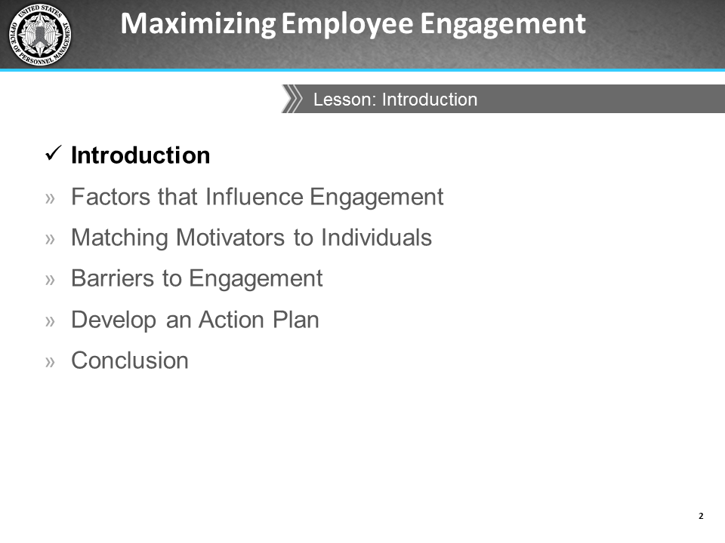
Icons | Instructor Notes
 | Talk about your experience in employee engagement and your qualifications to teach this course.
My name is _____________and I will be your facilitator today. I have been working at this agency for ___________years.
You are all in this course because you are interested in learning more about engagement and what you can do to increase engagement and productivity among your employees.
Evidence from both the academic and popular literature indicates that an engaged workforce leads directly to improved employee perceptions of the organization and its leadership. These perceptions of management are measured in the Federal Employee Viewpoint Survey (FEVS).
Are any of you familiar with the FEVS?
To ensure that we all have the same understanding, the FEVS is defined by OPM as “….a tool that measures employees' perceptions of whether, and to what extent, conditions characterizing successful organizations are present in their agencies. Survey results provide valuable insight into the challenges agency leaders face in ensuring the Federal Government has an effective civilian workforce and how well they are responding.”
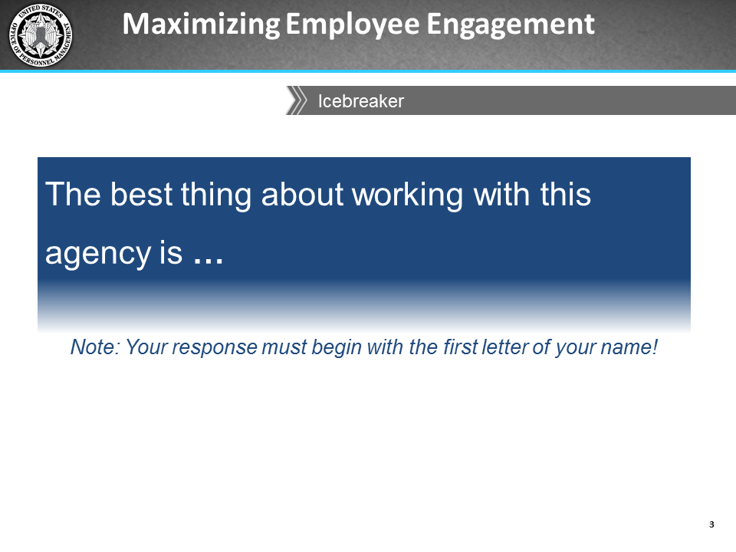
Icons | Instructor Notes
 | 10 minutes
Description
You will ask participants to introduce themselves and share the one or two things they like most about working in their agencies.
Resources
- Flip chart and marker

Instructions
- Capture the three FEVS engagement scale factors at the top of the page on the flip chart:
- Satisfaction with leadership (L)
- Satisfaction with supervisory support (S)
- Intrinsic work experience (W)
- Ask participants to introduce themselves and their positions and tell them to end their introductions by providing an answer to the statement on the slide.
- Tell them at least one of the two things they like must begin with the first letter of their name, and you will be documenting what they say on the flip chart.
- Introduce yourself first and share the one or two things you like about working in your agency. At least one thing begins with the first letter of your name.
Capture responses and highlight (with an asterisk) those that relate to engagement, for example:
- Pride in my work or agency
- Close relationship with my supervisor or manager
- Satisfaction with leadership
- Opportunity to perform well at work
- Sense of personal accomplishment
- Autonomous work environment
- Satisfaction with recognition received
- Prospect for future personal/professional growth
- Awareness of how my work relates to the agency’s goals and priorities

After all participants have responded, ask the class to link some of the responses to the three engagement scale factors in the FEVS:
- Satisfaction with leadership (L): Employees’ perceptions of the integrity of leadership, as well as leadership behaviors such as communication and workforce motivation.
- Satisfaction with supervisory support (S): The interpersonal relationship between worker and supervisor, including trust, respect, and support.
- Intrinsic work experiences (W): Employees’ feelings of motivation and competency relating to their role in the workplace.
Here are a few linkage examples:
- Satisfaction with recognition received = Satisfaction with leadership
- Close relationship with my supervisor or manager = Satisfaction with supervisory support
- Opportunity to perform well at work = Intrinsic work experience
- Capture their decisions by abbreviating each of the engagement factors (i.e., L, S, W) next to the responses from the icebreaker

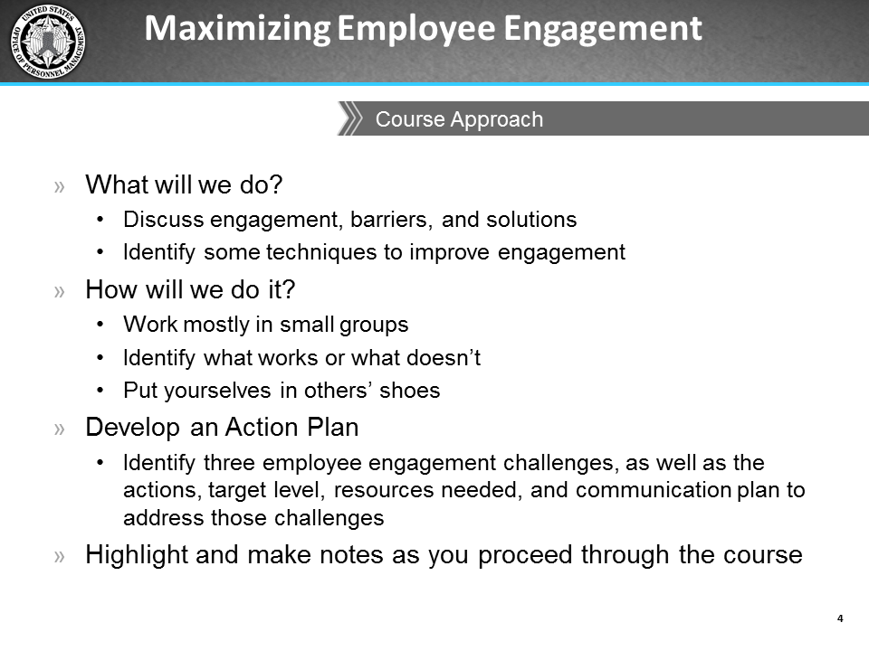
Icons | Instructor Notes
This section provides an overview of the course. Its purpose is to familiarize participants with the course structure and anticipated outcomes.
What will we do in this course?
We will identify, discuss, analyze your own engagement as well as your employees' engagement, factors that affect engagement, and interpersonal and organizational barriers.
We will also identify and discuss possible solutions and techniques to improve engagement.
Finally, you will develop an Action Plan with short- and long-term engagement goals that address challenges and possible areas of improvement. You will take the plan back to work with you and implement the actions you identified.

How will we do it?
The course is highly participatory.
There are individual activities as well as small group activities where you will report out your results and learn from each other.
We will then discuss what works or does not work when engaging your employees in your own agencies. I will ask you questions throughout the session to ensure that everyone has an opportunity to contribute and share their knowledge and experience.
We will develop an Action Plan
You will identify 3 employee engagement challenges, as well as the actions, target level, resources needed, and communication plan to address those challenges.
You can highlight and make notes in your Participant Guide as we proceed through the course, then refer to these notes when it is time to create your Action Plan.

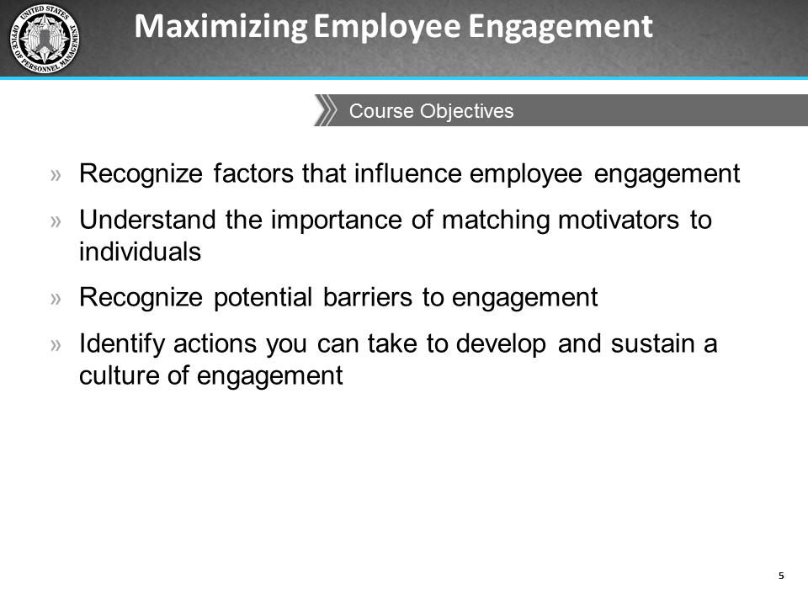
Icons | Instructor Notes
 | Review the course objectives
The purpose of this course is to:
- Reinforce the concept and importance of engagement
- Provide an environment that will encourage you-supervisors, managers, and executives-to be open to learning and practicing methods designed to increase the level of engagement among your employees
- Provide you with techniques to improve engagement within the organization
- Enhance your knowledge of engagement via classroom activities

Factors that Influence Engagement

Lesson Overview
Topics | Estimated Time (minutes)
Overview of Engagement | 20
You and Your Employees’ Engagement | 40
Total | 60

Lesson Objectives
- Identify job-related factors that influence levels of engagement for different individuals
- Recognize your roles as Federal leaders in fostering employee engagement

Activity Materials and Job Aids in the IG
- Activity: Factors that Influence Your Engagement (page 93)
- Activity: Challenges that Influence Your Employees’ Engagement (page 94)
- Job Aid: Debunking Myths about Employee Engagement (pages 115-116)
- Job Aid: Ways to Create a Culture of Engagement (page 117-118)
- Job Aid: Fast Track to Lowering Engagement (page 119)

Resources
To learn more about the topics in this lesson, please read the following beforehand:
- Catlette, B., & Hadden, R. (2912, Aug 17). How to foster outrageously awesome employee engagement. Fast Company. Retrieved from http://www.fastcompany.com/3000474/how-foster-outrageously-awesome-employee-engagement
- Coro Fellows Program in Public Affairs. (2013 Mar 22). With GSA Canceling Trainings, How Can Feds Develop New Skills? Retrieved from http://www.govexec.com/excellence/promising-practices/2013/03/gsa-canceling-trainings-how-can-feds-develop-new-skills/62004/#.UVBNyU6CY0Y.email
- U.S. Merit Systems Protection Board. (2008, Sep). The Power of Federal Employee Engagement. Retrieved from http://www.mspb.gov/netsearch/viewdocs.aspx?docnumber=379024&version=379721
- U.S. Merit Systems Protection Board. (2009, July). Managing for Engagement—Communication, Connection, and Courage. Retrieved from http://www.mspb.gov/netsearch/viewdocs.aspx?docnumber=437591&version=438697&application=ACROBAT
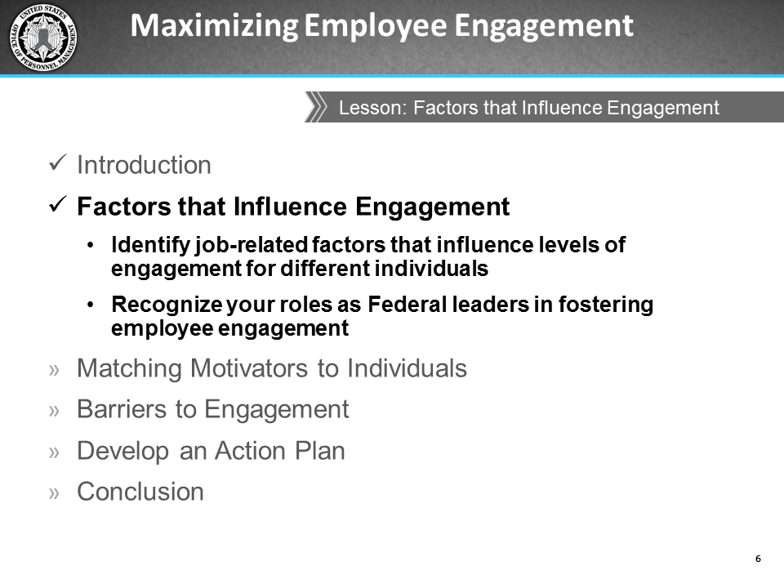
icons | Instructor Notes
 | Review the objectives for this lesson.

Overview of Engagement
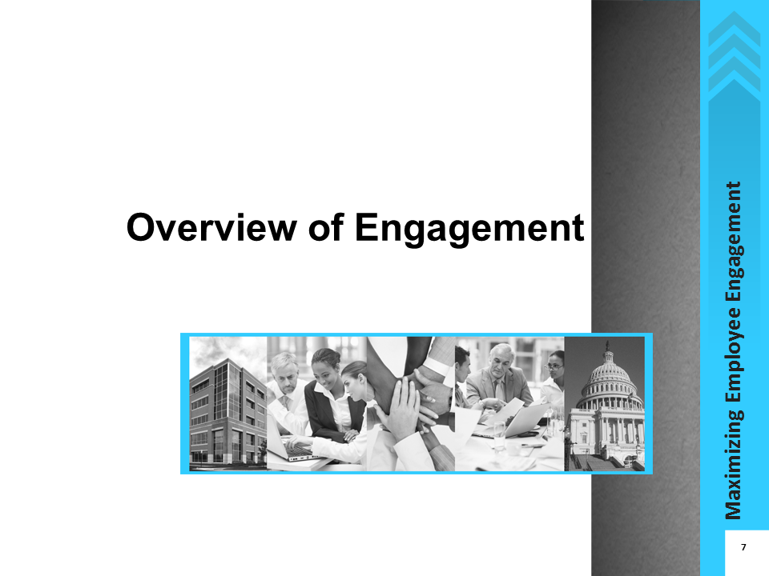
Icons | Instructor Notes
 | Let’s take a few minutes to review engagement by identifying characteristics of engagement and discussing myths we have heard about engagement.

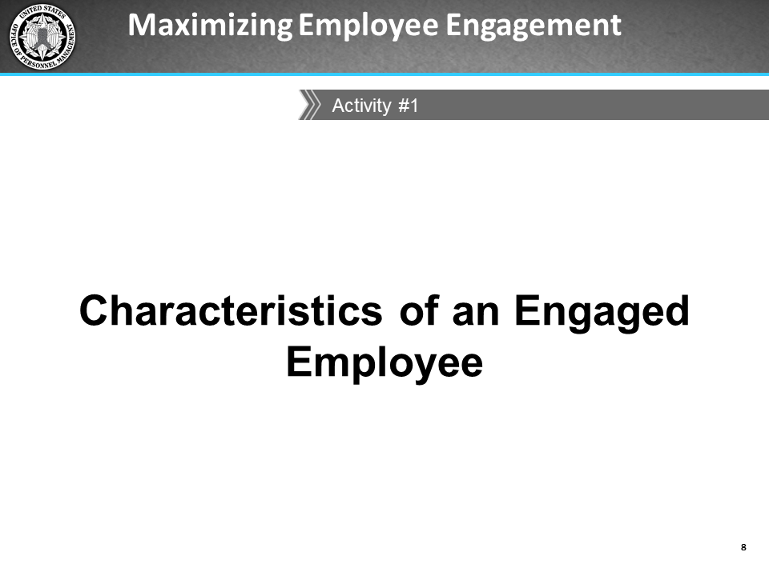
icons | Instructor Notes
 | 8 minutes
Description
You will ask participants to share ideas on characteristics of an engaged employee.
Resources
- Flip chart and marker
Instructions
- Ask participants to share their ideas on characteristics of an engaged employee.
- If participants are slow to offer responses, use questions to prompt a response.
What are characteristics of an engaged employee?
- What might the employee’s relationship look like with his or her manager?
- What might the employee’s behavior look like?
- What might their attitudes be?
- How might they feel about the organization/their work/their co-workers?
 | Capture participant responses on a flip chart.

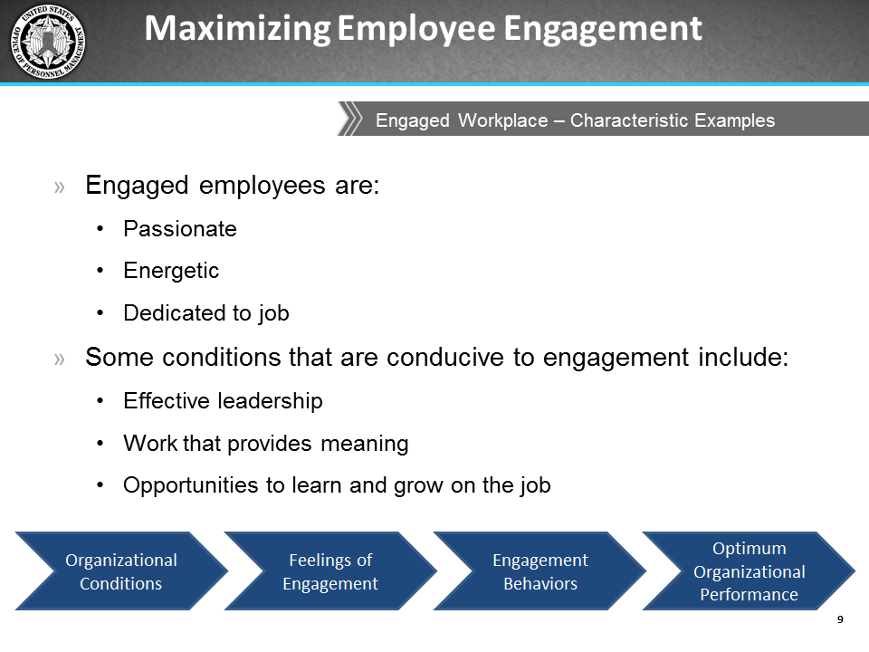
icons | Instructor Notes
Specific definitions of engagement abound, but in general, an engaged employee can be described as being fully involved in and enthusiastic about their work and the organization’s goals. The U.S. Merit System Protection Board (MSPB) defines employee engagement as “a heightened connection between employees and their work, their organization, or the people they work for or with.” “Engaged employees find personal meaning in their work, take pride in what they do and where they do it, and believe that their organization values them.” This then causes employees to produce better results for the organization.
OPM describes an engaged employee as someone who is:
- Passionate
- Energetic
- Dedicated to his/her job and organization

Conditions that are conducive to engagement include:
- Effective leadership
- Meaningful work
- Developmental opportunities to learn and grow
A variety of organizational conditions lead to feelings of engagement. This leads to manifestations of engagement, which in turn lead to optimal organizational performance. These are all connected; they do not occur in a vacuum.

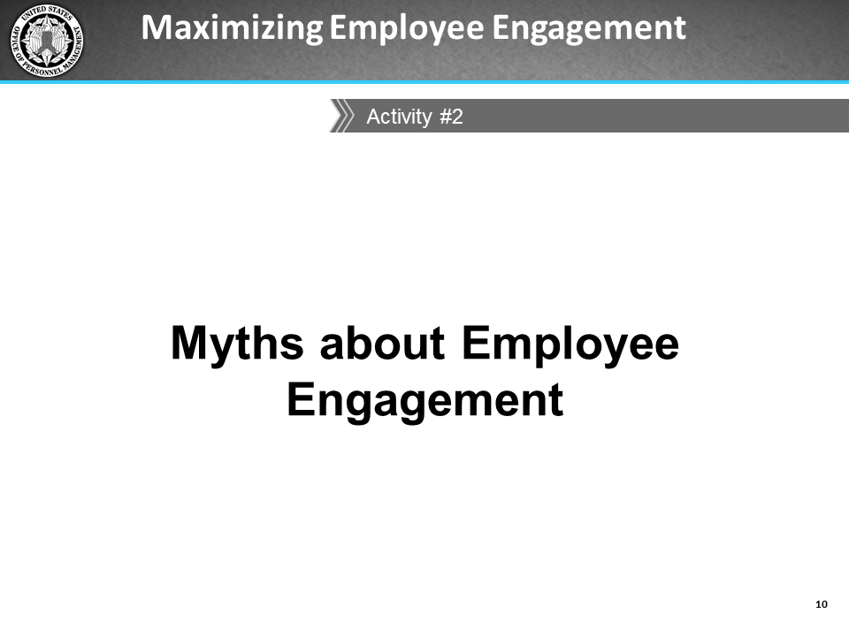
icons | Instructor Notes
 | 5 minutes
Description
Participants will share some of the myths they have heard about engagement or engaged employees. Lead the class in a discussion of any experiences they have had contrary to those myths, and then refer participants to a job aid that lists some myths and the realities of those myths.
Resources
- Flip chart and marker
Instructions
- Ask participants to share with the rest of the class some of the myths they have heard about employee engagement or engaged employees.
- Encourage them to record their thoughts in the Notes area of their PG while you also record their responses on a flip chart.
What myths have you heard about employee engagement or engaged employees? Here are a couple of examples I have heard:
- Money is the only thing that engages employees.
- I know what motivates me, so I know what motivates others.
- Do any of these ring a bell? What else have you heard?
 | Capture participant responses on a flip chart
 | Facilitate a brief discussion about whether participants have experienced anything contradictory to each of the myths they mention. If the class does not have many myths to report, use the myths on the next slide to prompt discussion.

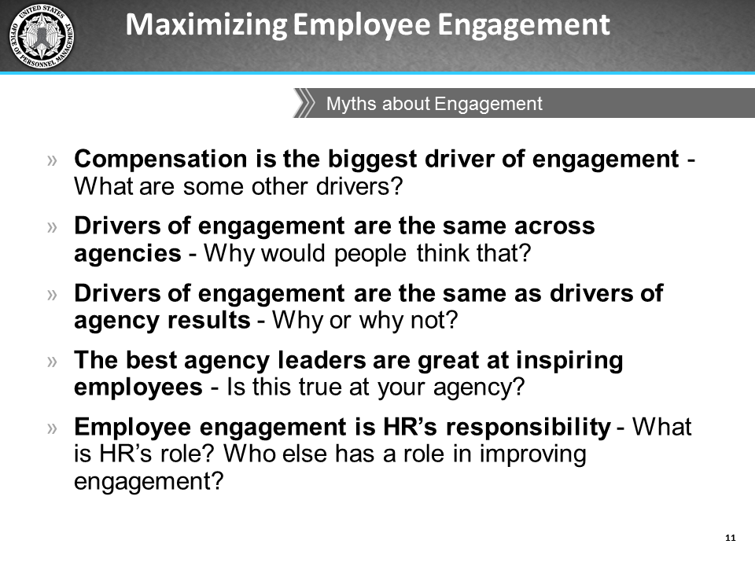
Icons | Instructor Notes
 | 5 minutes
Here are some examples of myths [do not read the ones the class has already stated]:
- Compensation is the biggest driver of employee engagement
- The drivers of employee engagement are the same in all agencies
- Employee engagement means hosting an event every now and then
- The best agency leaders are all great at inspiring employees
- Improving employee engagement is HR’s responsibility
Let’s go through some of these and vote whether you all think each is really a myth or a reality.
 | After each vote, use the job aid Debunking Myths about Employee Engagement on pages 115-116 in the IG to help explain why they are myths. For myths not included in the table, encourage the class to briefly discuss them and arrive at a collective decision as to whether it is a myth or reality.
 | Please refer to the job aid Debunking Myths about Employee Engagement on pages 63-64 of your PG for some of the myths we’ve just reviewed.
 | Are there any questions before we start the first lesson of this course, “Factors that Influence Engagement?”
 | If you are not able to answer a question, put it in the Parking Lot and come back to it later. You might have more insight as the course progresses, or other participants may be able to answer the questions.

You and Your Employees’ Engagement
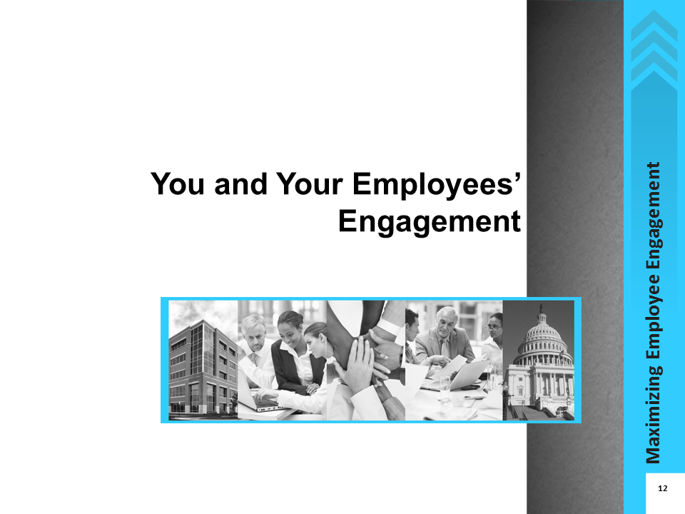
icons | Instructor Notes
 | Now let’s discuss job-related factors that influence your own engagement as well as your role as a Federal leader in fostering employee engagement.

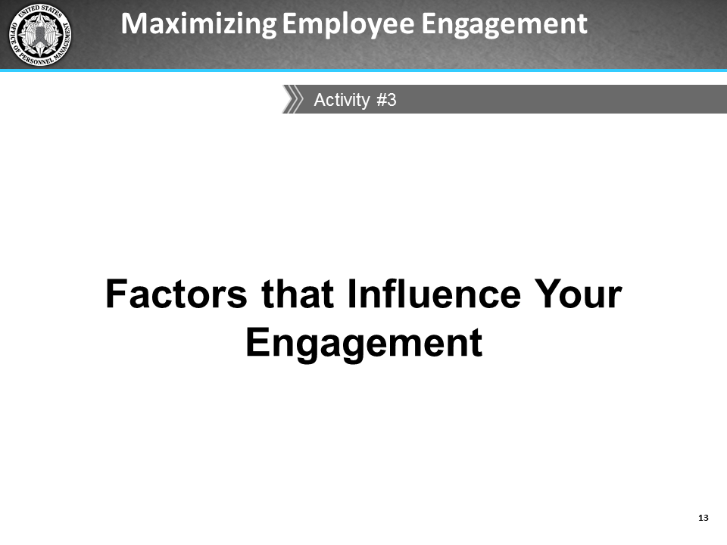
icons | Instructor Notes
 | 15 minutes
Description
You will ask participants to share factors in their work environments that promote or hinder their engagement. During the debrief participants will identify and discuss common themes in their responses, and how those themes might differ if their employees were asked the same questions. You will introduce participants to two job aids and remind them about the Action Plan at the end of the course.
Resources
- Flip chart and marker
Activity Materials and Job Aids in the IG
- Activity: Factors that Influence Your Engagement (page 93)
- Job Aid: Ways to Create a Culture of Engagement (page 117-118)
- Job Aid: Fast Track to Lowering Engagement (page 119)
- Tell participants to take a few minutes to reflect on a time when they felt engaged and/or disengaged at work. They can record their thoughts on the Factors that Influence Your Engagement activity on page 17 in the PG. They will share the factors with the rest of the class while you record their responses on a flip chart.
- Tell them you will also ask them to identify the common themes found in the responses.
Turn to the Factors that Influence Your Engagement activity on page 17 of your PG. Use this sheet to record your thoughts to the following questions:
- Think about a time, since you have become a supervisor, when you felt engaged and/or disengaged at work?
- What was taking place at the time that affected your engagement?
- What made you feel this way?
- When you felt engaged what was the relationship like with your employee(s)?
- When you felt disengaged what was the relationship like with your employee (s)?
You will be asked to share your reflections with the rest of the class.
 | Capture participant responses and the common themes on the flip chart.
 | Facilitate a class discussion that leads to participants thinking about how their role as a leader may influence the engagement levels of their employees. Being able to see how some of the factors they have just identified affect their own engagement as well as their employees’ engagement will help them more effectively manage their staff and foster engagement.
Please refer to the two job aids in Section 2 of your PG:
- Ways to Create a Culture of Engagement (page 65)
- Fast-Track to Lowering Engagement (page 67)
Both of these documents describe some of the things to keep in mind in terms of your actions and behaviors, as well as how the culture you create can affect employee engagement.
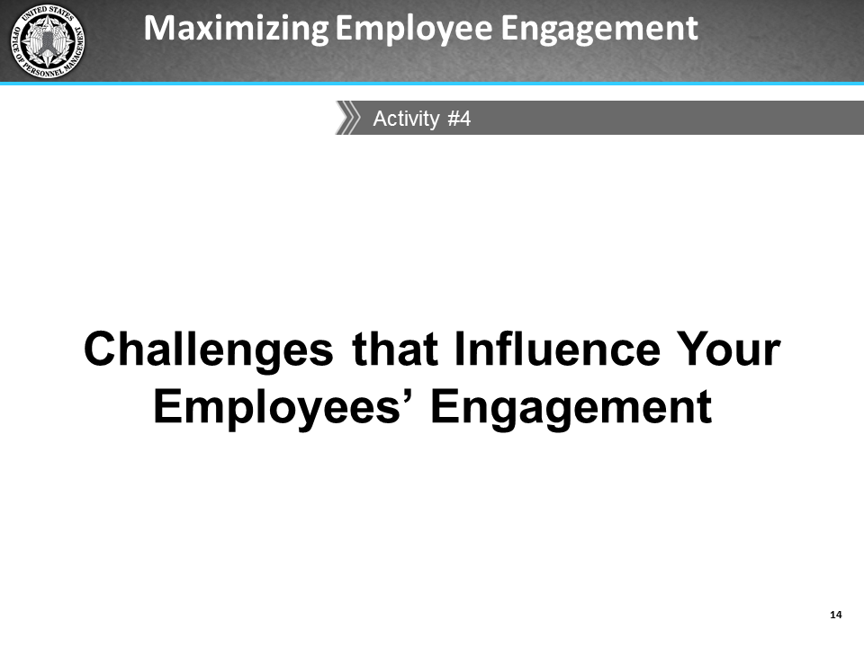
icons | Instructor Notes
 | Now let’s discuss factors that can affect your employees’ engagement. You have a strong influence over your employees’ well-being, motivation, and overall engagement. Being able to see the effect of how a variety of factors influence their engagement will help you to more effectively manage your employees and increase their engagement.
 | 15 minutes
Description
In small groups, participants will identify specific challenges to engagement they have seen among their employees and then report their observations to the rest of the class. During the report out, they will help each other identify methods to overcome each challenge. They will then decide where the responsibility lies for overcoming each challenge they identify.
Resources
- 2 Flip charts and 2 different colored markers
Activity Materials and Job Aids in the IG
- Activity: Challenges that Influence Your Employees’ Engagement (page 94)
Presentation
- Ask participants to form small groups of 4-5 (depending on class size). Ask one member of each group to volunteer to be the reporter; this person will report out the group’s comments to the rest of the class.
- Ask participants to turn to the Challenges that Influence Your Employees’ Engagement activity (page 19) in the PG.
- Tell participants that they will complete the activity in their small groups and report out their responses. As a class, they will help identify solutions to address and overcome each of the challenges each group has identified.
- Tell them you will also be capturing their responses on flip charts.
Think back to before you became a supervisor.
What challenges did you have with your manager or supervisor that affected your engagement?
What are some of the specific challenges to engagement you have seen among your employees?
Discuss your responses to these questions within your small groups and designate a group member to be the reporter. As a class, we will help each other identify solutions to overcome each challenge, as well as assign responsibility for addressing the challenge.
Arrange two flip charts side-by-side while participants are discussing the challenges within their groups:
- Flip chart 1 – capture the challenges each group identifies
- Flip chart 2 – capture the solutions participants provide to address the corresponding challenges on flip chart 1
Go around the room and have each group report out their challenges. Chart these challenges on flip chart 1. Note when the same or very similar challenges are mentioned.
Think back to the characteristics of a disengaged employee. Do you or any of your direct reports exhibit these characteristics? If so, which one can you attribute to your role as a supervisor?
What about a lack of or ineffective communication from you as their supervisor? How do you think employees feel when they do not know what is going on with you—their boss, the team, or even the organization as a whole?
Do you feel you have enough visibility or face-time with your staff? On average, how much face-to-to-face time do you think you give to them? When you were an employee, is this something that would have contributed to your engagement?
Once each group has reported, review each challenge and ask the class what actions they think could be taken to overcome each identified challenge. Chart these solutions on flip chart 2 with a different color marker than was used on flip chart 1.
If participants have a difficult time identifying challenges, the next slide has possible methods to address some challenges.
 | Summarize the challenges and solutions participants have identified, as well as any discussion/comments surrounding them.

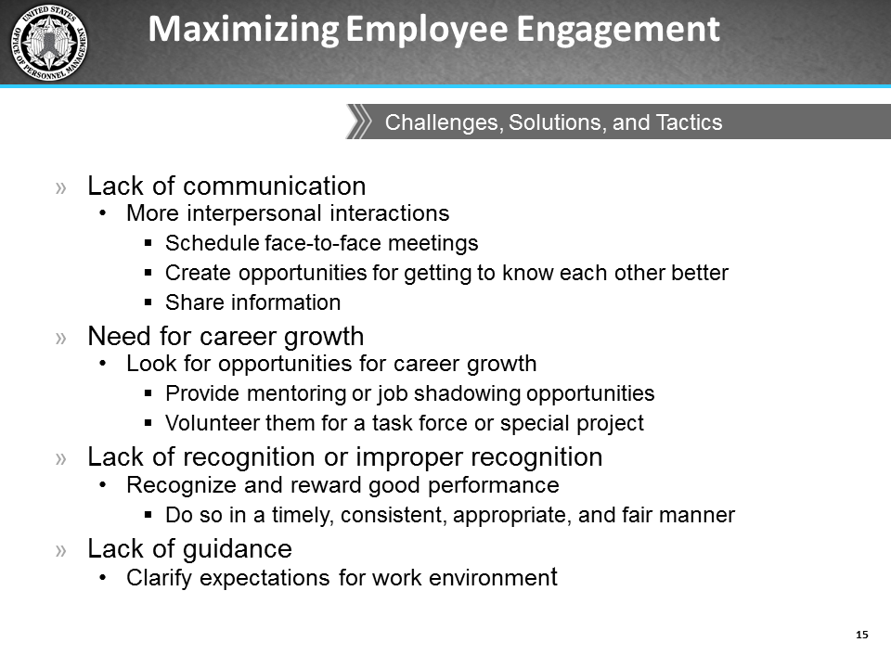
icons | Instructor Notes
Here are some sample ways to address some of the challenges we have identified:
- Talk face-to-face with employees, either individually or as a group (e.g., catch up on what they have been doing, update them on anything going on within the organization, ask them for feedback/questions/concerns).
- As an agency leader, get out and walk around the floor to have more personal interactions with employees.
- Look for opportunities for career growth (e.g., help them find informal/formal mentoring or job shadowing opportunities, volunteer them for a task force or special project).
- Recognize and reward good performance. Ensure you are rewarding in a timely, consistent, appropriate, and fair manner. Ask each employee how he or she prefers to be recognized.
- Conduct realistic job previews explaining the work environment and job expectations to prospective employees. When their experience on the job matches their expectations, employees are more likely to be satisfied and engaged in their work, and may also have a better belief in the trustworthiness of the organization as a whole.
 | Ultimately, it is important for supervisors and managers to not only be able to identify factors that might affect engagement among their staff, but also be able to understand whose responsibility it is to address those challenges and understand what is within their span of control and influence. Leaders should recognize that employees also have some responsibility for their engagement and are expected to work with their supervisor to address their engagement concerns.

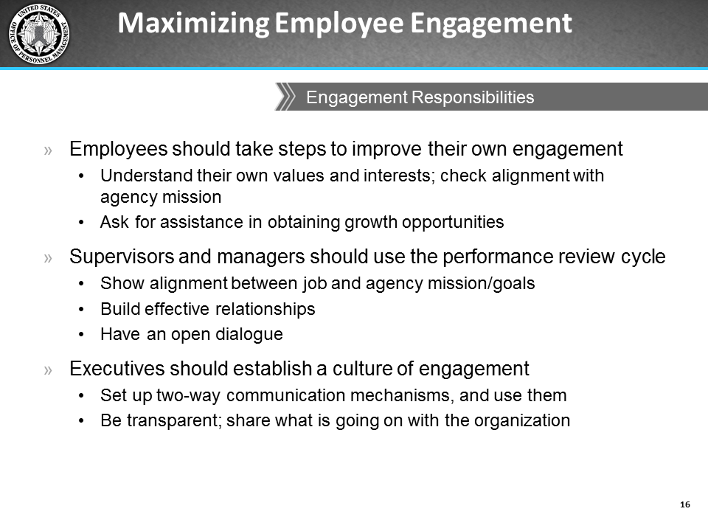
icons | Instructor Notes
Regardless of the challenge or solutions identified, employees, supervisors, managers, and executives have different roles in employee engagement.
Employees should understand their own values, interests, talents, and career aspirations.
Those of you who are supervisors and managers should use activities that are part of the performance review cycle to help your employee see the alignment of their jobs with the organization's objectives, and ultimately coach, forge effective relationships, and have open dialogue with your employees. Discussing performance objectives is a natural lead-in to this topic.
Everyone-supervisors, managers, and executives- should establish open and two-way communications with those they supervise and manage, build trust, and create a culture that supports high performance and engagement.
 | Encourage brief class discussions on how participants can to talk with their employees and ways participants can build trust with their employees.
 | In the next lesson, we will focus on your role as leaders in promoting a culture of engagement. Later in the course we will discuss organizational barriers that may lie outside of your individual control and the actions you can take. This activity should help you have a better understanding of, or at least start thinking about, your responsibilities as supervisors, managers, and executives in fostering a culture of engagement. This activity, as well as the other activities in the remaining lessons, will be particularly important and helpful for you when you create your Action Plans.
 | Note: If you are unable to answer a question, add it to the Parking Lot and return to it later. You may have more insight as the course progresses, or other participants may be able to answer the questions.

Matching Motivators to Individuals

Lesson Overview
Topics | Estimated Time (minutes)
Job Characteristics | 45
Leadership Styles | 30
Total | 75

Lesson Objectives
- Recognize job design as a motivator of engagement and understand how to use it to increase engagement.
- Understand how their leadership styles can affect employee engagement.

Activity Materials and Job Aids in the IG
- Activity: Different Strokes for Different Folks (pages 95-96)
- Activity: Matching your Leadership Style to the Situation (pages 97-100)

Resources
To learn more about the topics in this lesson, please read the following beforehand.
Job Characteristics
- U.S. Merit Systems Protection Board. (2012, Nov). Federal employee engagement: The motivating potential of job characteristics and rewards. Retrieved from http://www.mspb.gov/netsearch/viewdocs.aspx?docnumber=780015&version=782964
Employee Motivation
- Lindner, J. R. (1998). Understanding employee motivation. Extension Journal, 36 (3). Retrieved from http://www.joe.org/joe/1998june/rb3.php
- Emotional Intelligence
- Goleman, D. (1998). What makes a leader? Harvard Business Review, 76(6), 93-102.
- Goleman, D., Boyatzis, R., & McKee, A. (2001). Primal leadership: The hidden driver of great performance. Harvard Business Review, 79(11), 42-51.
- Emotional and Social Competency Inventory (ESCI): http://www.haygroup.com/leadershipandtalentondemand/ourproducts/item_details.aspx?itemid=58&type=1&t=1
Leadership Styles
- Goleman, D. (2000). Leadership that gets results. Harvard Business Review, 78(2), 78-90. Retrieved from http://www.haygroup.com/downloads/fi/leadership_that_gets_results.pdf

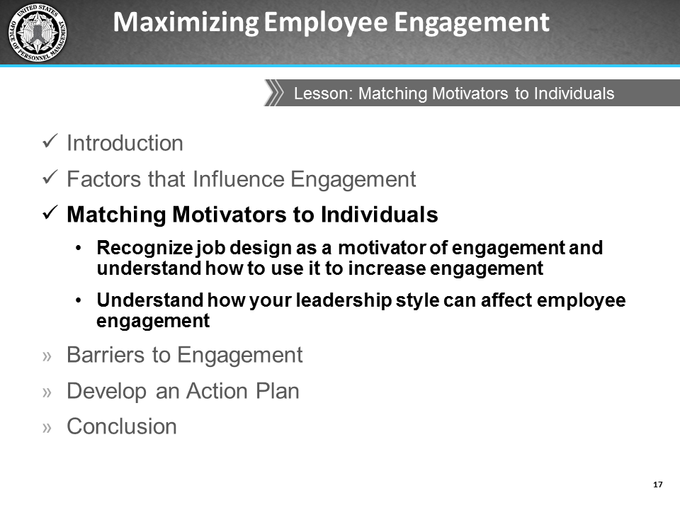
icons | Instructor Notes
 | Review the objectives for this lesson.
 | In this lesson we will discuss the importance of job characteristics in motivating employees. We will also learn about different leadership styles and their impact on engagement.

Job Characteristics
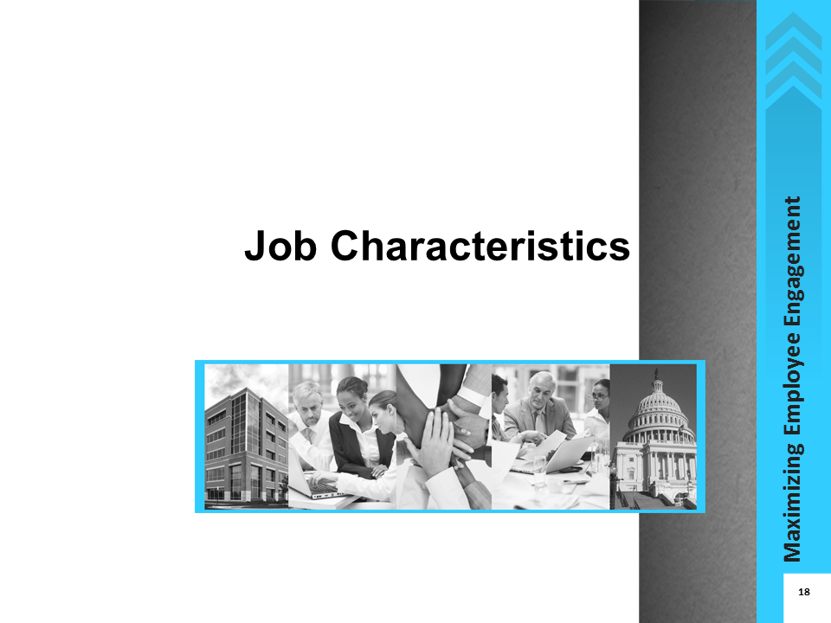
icons | Instructor Notes
Recall that employee engagement is “a heightened connection between employees and their work, their organization, or the people they work for or with.” Employee motivation can be thought of as the inner force that drives employees to accomplish organizational goals. Fostering that inner force helps increase their connection with their work and the organization.
Job design, and particularly job characteristics, can be a major motivating factor for employees. MSPB describes job design as the structuring of jobs to maximize desirable characteristics. For example, jobs can be designed to increase production efficiency, minimize physical strain, or maximize the extent to which they are motivating to the worker. According to MSPB, good job design supports organizational efficiency and effectiveness. A well-structured job – one that maximizes desirable job characteristics – can affect employee motivation, which is a necessary ingredient for engagement and performance.
MSPB describes job characteristics as the core features, or characteristics, of jobs which affect employee motivation and performance. Job characteristics include skill variety, task identity, task significance, autonomy, and feedback.
Just as your employees have different interests and personalities, they will have different preferences when it comes to different motivators. Changing their job characteristics can positively impact their motivation. It is important to recognize what those preferences are for your employees as well as understand how to leverage these preferences to increase their individual engagement.

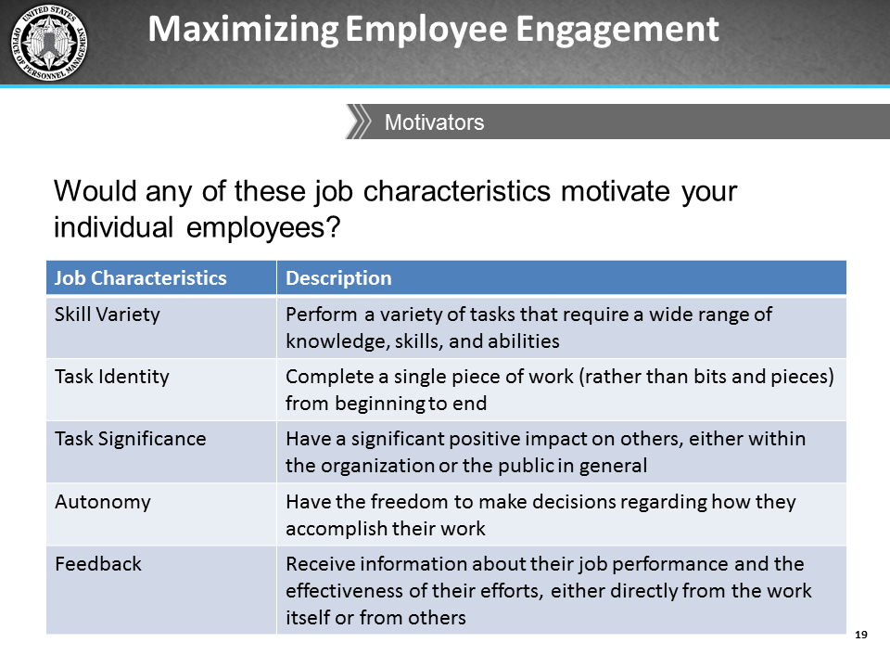
icons | Instructor Notes
During the icebreaker activity, I asked you to share what you liked best about working with your agency. We then linked your responses to the three FEVS factors of satisfaction with leadership, satisfaction with supervisors, and intrinsic work experience. Some of your responses are what MSPB defines as drivers of engagement, such as pride in one’s work, satisfaction with leadership, and perceptions of a positive work environment. MSPB also states that these three particular factors can be viewed as characteristics of the job.
The other drivers of engagement are satisfaction with recognition, prospects for growth and development, and opportunity to perform well. As a supervisor or manager, your responsibilities include understanding the job characteristics that help motivate your employees, then designing their jobs to emphasize those characteristics.
This type of attention allows employees to see that you care about them and understand them as individuals, which can, in turn, foster engagement.
Look at the job characteristics on this slide. These are the five job characteristics the MSPB used in their 2012 study titled “Federal Employee Engagement: The Motivating Potential of Job Characteristics and Rewards.” These job characteristics reflect opportunities for development, skill building, and feedback, all of which are important factors in engagement.
The MSPB report also identified three approaches supervisors and managers can take to modify job characteristics to improve motivation:
- Job Enlargement - expand employees’ responsibilities within their current jobs to increase their knowledge and skill sets
- Job Rotation - assign employees tasks typically performed by others to broaden knowledge and skill sets
- Job Enrichment - provide employees with more independence, responsibility, and accountability in performing assigned tasks

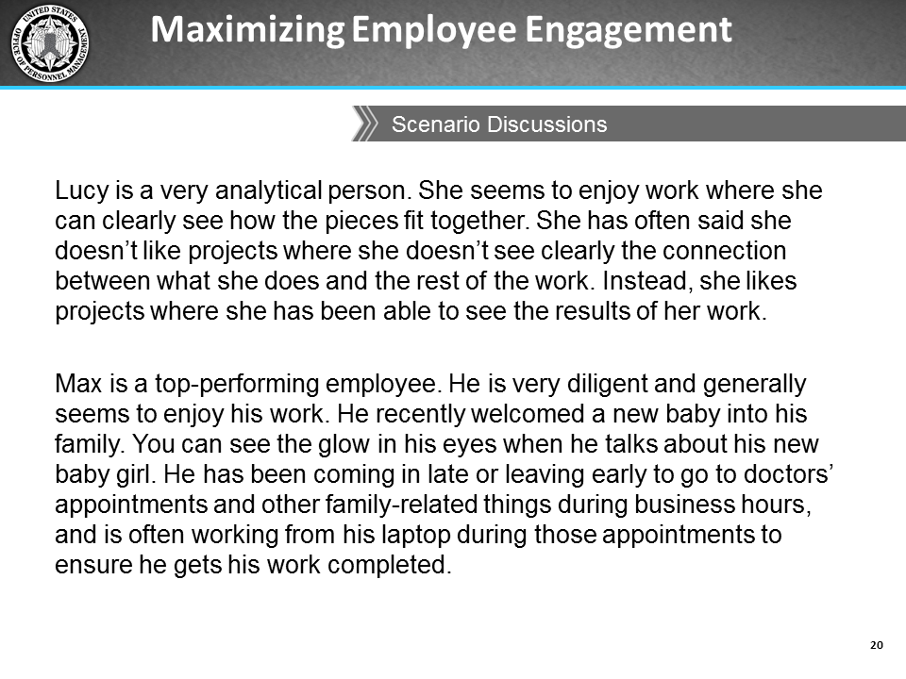
icons | Instructor Notes
 | If time permits, discuss both scenarios with participants. Otherwise, pick one and use that for discussion.
 | Let’s walk through one or two sample scenarios together about fictitious employees to help prepare you for the next activity. In these scenarios, we will identify which of these job characteristics would enhance the employee’s position, improve motivation, and ultimately help the employee become more engaged. We will also quickly talk about how we would go about modifying the identified job characteristic.
 | Scenario 1 response:
 | The job characteristics the manager should focus on may be task identity, task significance, and feedback. Encourage discussion of what her manager could do to modify these job characteristics (e.g., take on more project/task leadership roles).
 | (Time permitting) Scenario 2 response:
 | The response may be that Max might benefit from his manager focusing on the autonomy characteristic of his job. Encourage discussion of what exactly his manager could do to modify this, or other, job characteristic (e.g., granting telework, designating a work from home day, assigning him to more projects that do not have to be completed in the office).

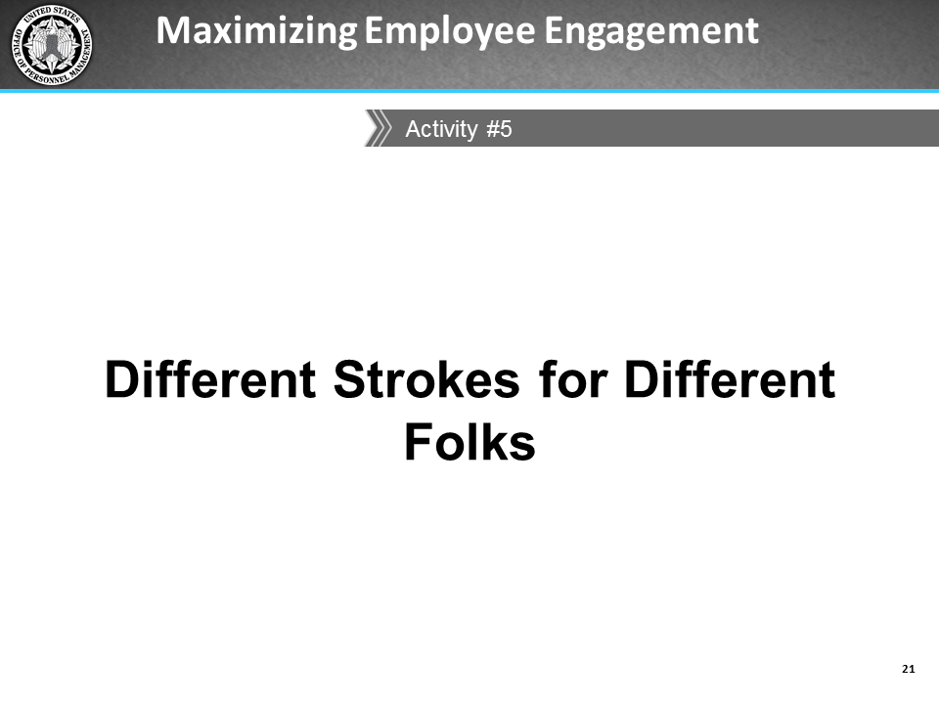
icons | Instructor Notes
 | 15 minutes
Description
Working individually, participants will fill out the table on the second page of the activity. For each job characteristic noted, they will describe how much authority they think they have in making modifications to each job characteristic and what change they would make to modify each job characteristic. They will report out their responses for a class discussion.
Activity Materials and Job Aids in the IG
- Activity: Different Strokes for Different Folks (pages 95-96)
Instructions
- Ask participants to turn to the Different Strokes for Different Folks activity on pages 27-29 in the PG.
- Instruct participants to complete the table provided on the second page of the activity.
- Tell participants they will be asked to share their responses so the class can provide feedback and other suggestions.
For each job characteristic noted in the first column, describe how much authority you think you have to make modifications to each job characteristic for your staff. Also describe how you would modify the job characteristic to enhance motivation. If you do not have the authority to change some job characteristics, who does? Who would you talk with to see what is possible?
Keep in mind the nature of the work your team usually performs, HR policies, the needs of the organization, and the need to be fair, objective, and transparent while you consider modifying job characteristics.

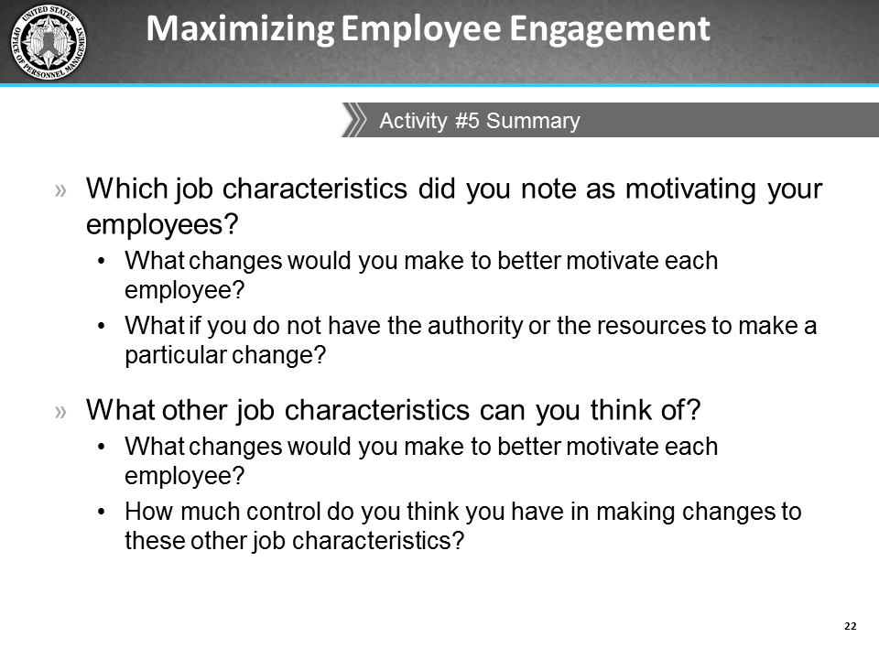
icons | Instructor Notes
Encourage participants to share a few of the job characteristics that motivate their employees.
Use the following statements to help facilitate the discussion:
- How they can realistically make those modifications (i.e., do they have control, authority or resources).
- How they would ensure that a particular job characteristic would indeed motivate a particular employee.
- How they would ensure transparency and fairness for other employees as they are making these modifications for one person so they do not appear to show favoritism.
Different individuals are motivated by different aspects of their job. As managers, you should know your employees well enough to try to create conditions that give employees the opportunity to work in a way that motivates them. Some things you can do to learn more about your employees include:
Take note of your employees’ preferences and styles in their interactions with others. Note how they receive feedback from you, and take time to understand their perspective, opinions, needs, and interests.
Confirm your assumptions with employees by asking them about their job preferences.
Be realistic and aware of which aspects of their jobs you can control/modify.
Remember to maintain transparency and fairness to others when making job modifications.
Remember to use the notes you have taken during this activity to help inform your Action Plans at the end of the course.

Leadership Styles
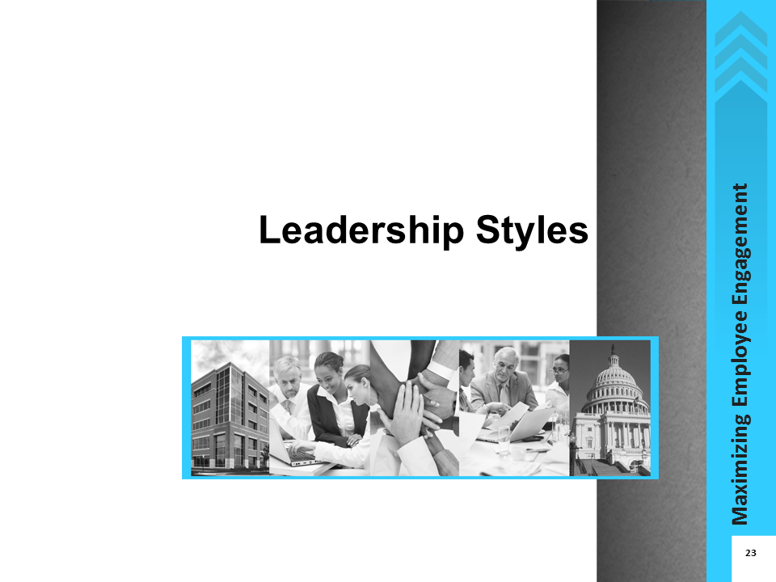
icons | Instructor Notes
 | Now let’s discuss the importance of matching your leadership style to different situations. A key component of engagement is your leadership style. You may think that your style is mainly a function of your personality, but it is also important to know that your leadership style can increase and decrease employee engagement. You need to be flexible and adapt your leadership style to the situation. This ability can improve your employees’ engagement levels, job performance, and ultimately, the organizational climate.

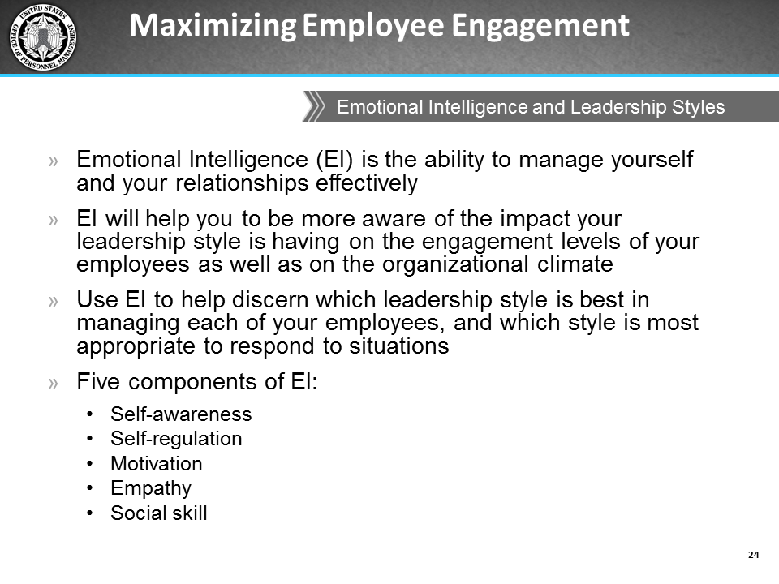
icons | Instructor Notes
The leadership styles used in particular situations can evoke different feelings within employees, from self-confidence and responsiveness to resentment and dissatisfaction. You should always be aware of the impact your leadership style has on your employees as well as on the organizational climate.
Emotional Intelligence (EI) can help determine which leadership style is most appropriate for each of your employees in general, and which style is most appropriate for different situations.
Well-known author and psychologist Daniel Goleman describes emotional intelligence (EI) as “the ability to manage yourself and your relationships effectively.”
OPM’s definition of Emotional Intelligence is, “a type of social competence involving the ability to monitor one's own and others' emotions, to discriminate among them, and to use the information to guide one's thinking and actions.”
 | When discussing EI, refer to Components of Emotional Intelligence (page 100 in the IG) to review descriptions of each of the five EI components.
EI includes the following components:
- Self-awareness
- Self-regulation
- Motivation
- Empathy
- Social skill
You should be aware of your own level of emotional intelligence. Several resources to assess your emotional intelligence are available online.
Goleman also identified six leadership styles, which spring from the different components of EI. These six styles are coercive, authoritative, affiliative, democratic, pacesetting, and coaching. The ability to switch among these styles helps build the best organizational climate.
Please turn to the Components of Emotional Intelligence on page 37 of your PG for a better understanding of these styles.
We will now do a quick activity using these six leadership styles.

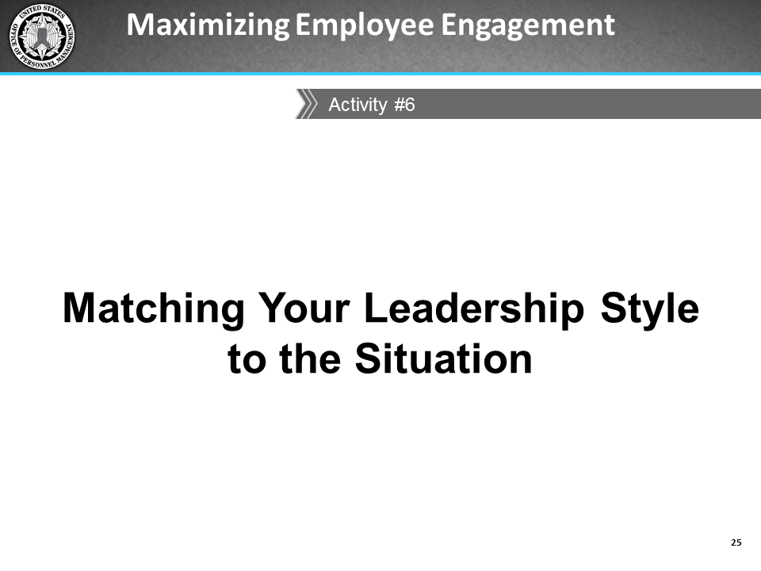
icons | Instructor Notes
 | 20 minutes
Description
Working individually, participants will complete the Matching Your Leadership Style to the Situation activity which asks them to read several situations and indicate how they would deal with each situation. After participants have finished, you will review each of the situations as a class and have participants share some of their responses to each situation. Encourage a discussion of whether or not that is the most effective leadership style in each given situation.
Activity Materials and Job Aids in the IG
- Activity: Matching your Leadership Style to the Situation (pages 97-100)
Instructions
- Ask participants to turn to pages 34-37 in their PG.
- Read the instructions aloud to the class.
 | This activity presents a list of situations in which you will need to indicate the leadership style you would normally use in each situation to maintain an engaged team. Consider factors such as your underlying emotions, your team’s goal in that situation, and the overall impact on the organizational climate. Be prepared to share your responses during the follow-up discussion of this activity.
Review each of the situations described in the handout and ask for volunteers to share their responses and the factors they considered in making their decision.
Note that the suggested appropriate leadership style (according to Goleman) has been prefilled in your Instructor Guide to help you in this follow-up discussion of which style may be most effective in the situation.
 | Remember that your leadership style can influence your team engagement – whether it is how a crisis is handled, how information is gathered and used, how decisions are made, or how leaders motivate and engage employees.

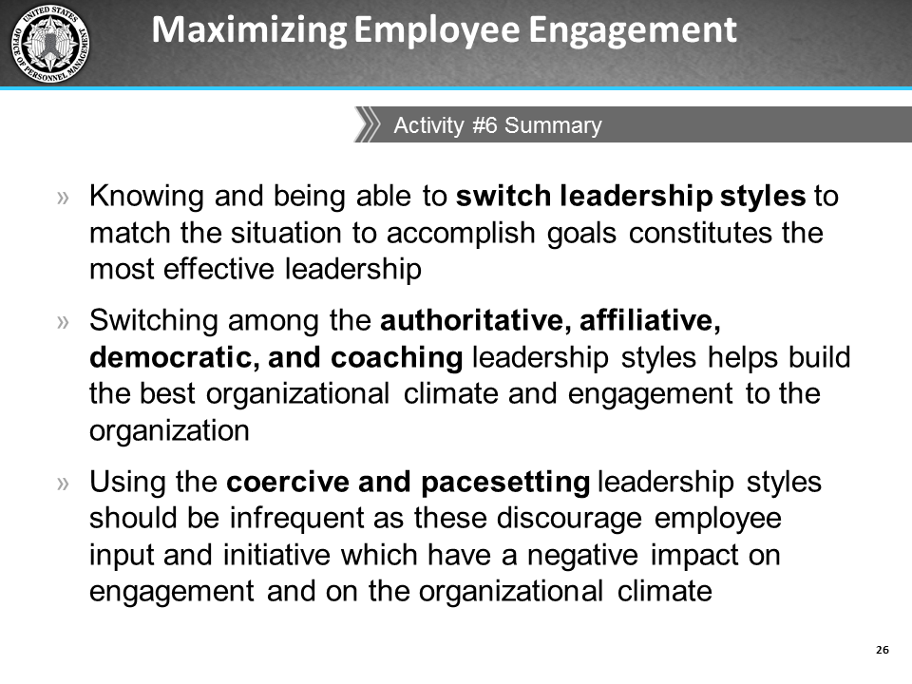
Instructor Notes
Remember that leadership style influences the organizational climate. A leadership style can be described in terms of how a crisis is handled, how information is gathered and used, how decisions are made, and how leaders motivate and engage employees.
As we have just discussed, different leadership styles impact engagement in various ways.
There is no perfect way to manage. There are pros and cons to each leadership style, but the most effective leader is one who understands and is able to use different styles in different situations.
Some employees may be more receptive to one style or another. This is why it is important to know your employees, their personality, and their motivators.
The authoritative, affiliative, democratic and coaching leadership styles contribute most positively to the organizational climate and employee engagement, while a leader who constantly uses the coercive or pacesetting styles has the most negative impact on the climate and engagement. The most effective leaders use a combination of styles to accomplish goals
I suggest you keep in mind some of the discussion from this activity as you think about the actions/recommendations you want to implement in the Action Plan you will develop as the last activity of this course.

Barriers to Engagement

Lesson Overview
Topics | Estimated Time (minutes)
Interpersonal Barriers | 45
Organizational Barriers | 20
Total | 65

Lesson Objectives
- Recognize potential interpersonal barriers to employee engagement.
- Identify and understand potential organizational barriers to employee engagement.

Activity Materials and Job Aids in the IG
- Activity: Your Interpersonal Barriers (page 101)
- Activity: Role Play (pages 102-103)
- Six Leadership Style cards (pages 105-109) to distribute one to each group
- Job Aid: Other Government Agencies' Strategies to Drive an Engaged Organizational Culture (pages 120-124)
- Job Aid: Alternative Non-monetary Ways to Encourage Training and Development (page 125)

Resources
- Interpersonal Barriers
- Classle. (n.d.) Interpersonal barriers in communication. Retrieved from https://www.classle.net/content-page/interpersonal-barriers-communication#
- Organizational Barriers
- Attridge, M. (2009). Employee work engagement: Best practices for employers. Research Works: Partnership for Mental Health, 1, 1-12.
- Branham, L. (2005). The 7 hidden reasons employees leave: How to recognize the subtle signs and act before it's too late. New York, NY: AMACOM Books.

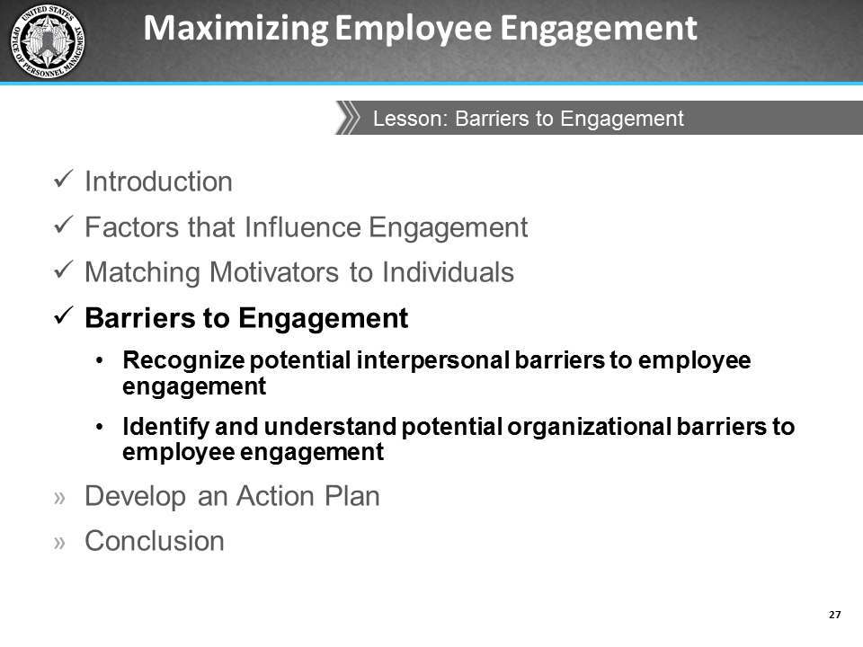
icons | Instructor Notes
 | Review the lesson objectives.
 | In this lesson we will discuss potential interpersonal and organizational barriers to employee engagement. This discussion will be supplemented with two activities.

Interpersonal Barriers
icons | Instructor Notes
Interpersonal barriers are often the result of personal attitudes or habits that we use when relating to others, and that we often have control over changing.
This includes our gestures and movements, facial expressions, appearance, vocal cues, word choices, and how we communicate with others. The connections that people build in an organization—with peers, supervisors, and subordinates—are a big factor in determining their individual level of engagement.
Interpersonal barriers can result from ineffective communication between two or more people. Some of the most common reasons for interpersonal barriers include:
- Limited vocabulary
- Emotional outbursts
- Communication selectivity
- Poor listening skills
- Cultural differences
It is important to recognize potential interpersonal barriers to employee engagement you may have in interactions with your employees.

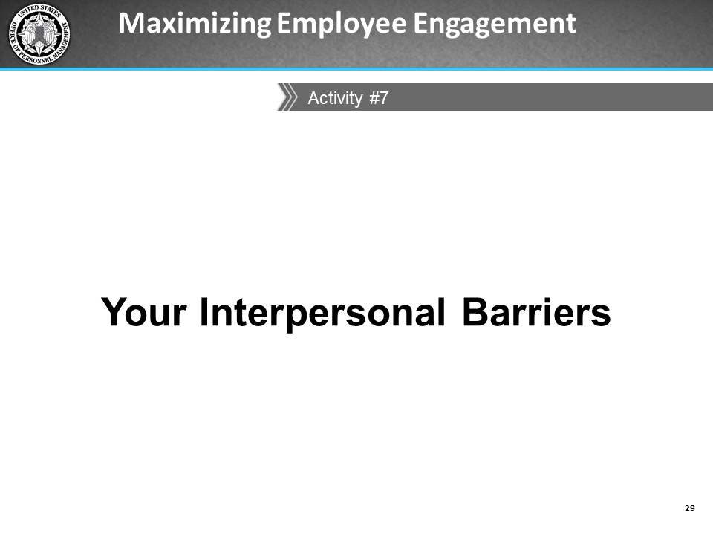
icons | Instructor Notes
 | - 10 minutes
Research shows that employees leave their managers, not their organizations. Interpersonal relationships can influence employee engagement. In particular, interpersonal relationships with supervisors or managers are some of the strongest predictors of engagement.
The goal of this activity is to give you an opportunity to think about how you can enhance communication and interactions with your employees. The interpersonal barriers you identify in this activity may help you determine some actions to include on your Action Plan.
Description
Working individually, each participant will take a moment to list the interpersonal barriers they think exist in their interactions with their employees, and which may affect their employees’ engagement levels. Participants will also list solutions to what they can do to overcome the barriers.
Activity Materials and Job Aids in the IG
- Activity: Your Interpersonal Barriers (page 101)
Instructions
- Ask participants to turn to the Interpersonal Barriers activity on pages 41-42 of the PG.
- Tell participants to take a few moments to write down examples of interpersonal barriers that exist in their interactions with their employees. Their examples must be in the form of “I” statements, for example:
- I don’t have a lot of time to do a face-to-face with everyone (many of my employees are in the field).
- I have a hard time giving feedback.
- I don’t communicate because I assume my employees will handle issues on their own; I don’t want to seem like a micro-manager.
- Tell them that when they are finished writing these “I” statements, they should reflect on the impact those barriers have on their communication style. They will then think about and list ways to address these barriers.
- Tell them they do not need to report their response if they are uncomfortable, but you will be asking for volunteers to report some of their answers. The class will brainstorm other ideas/ways to address/minimize the interpersonal barriers.

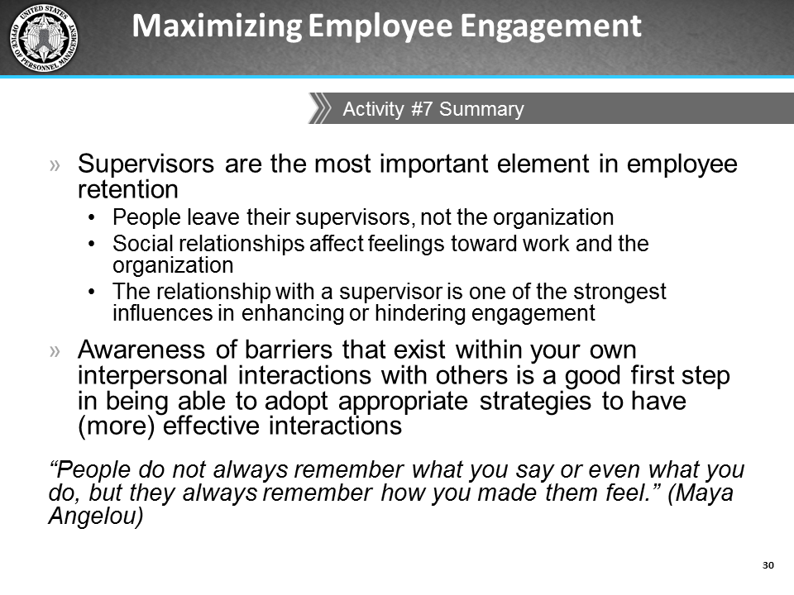
icons | Instructor Notes
Being aware of barriers that exist in your interpersonal relationships with others is a good first step in being able to adopt strategies that lead to more effective relationships.
How you make your employees feel leaves a longer-lasting impression than what you tell them or what you do as their supervisor.

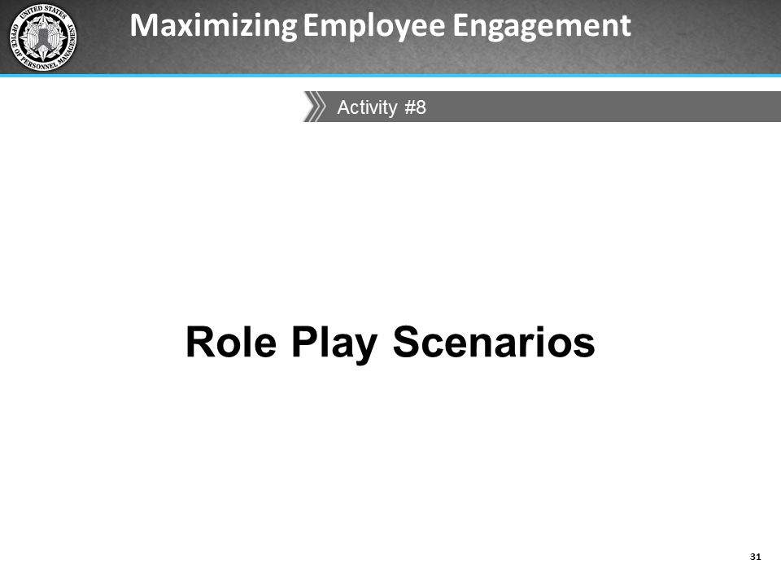
icons | Instructor Notes
 | - 20 minutes
Description
Separated into six groups, each group must develop a plan of action to improve their department’s employee engagement EVS scores. One member in each group is assigned the role of supervisor, while the rest of the group members play the roles of a mixture of employees and members of other teams. The participants must document their decisions in the Action Plan form of the Role Play (on page 95 of the IG), and stay in character the entire duration of the role play exercise.
Activity Materials and Job Aids in IG
- Activity: Role Play (pages 102-103)
Instructions
- Separate the class into six groups of 3-4 members.
- In cases of very small class sizes (i.e., 18 or less), ensure there are at least six groups of two pairs of participants, where one person plays the role of the leader and the other plays the role of the team member. Any remaining participants also play the role of a team member.
- For groups of 3 or more, ask for a volunteer from each group to play the role of a leader, while the rest of the group members play the roles of team members.
- Ask participants to turn to the Role Play activity on pages 44-45 of their PG.
- Briefly review the descriptions of each of the leader styles. Participants may refer to page 34 in the PG if they need to review these characteristics.
- Give each leader in the group one of the leader styles [the pre-printed Leadership styles cards on pages 105-109 of the IG], and tell them to refer to the description of the leader styles they were given.
- Instruct these leaders not to allow their group members to see the leader style you have assigned them. They must stay in character while completing the task in the activity.
- Answer any questions they have.

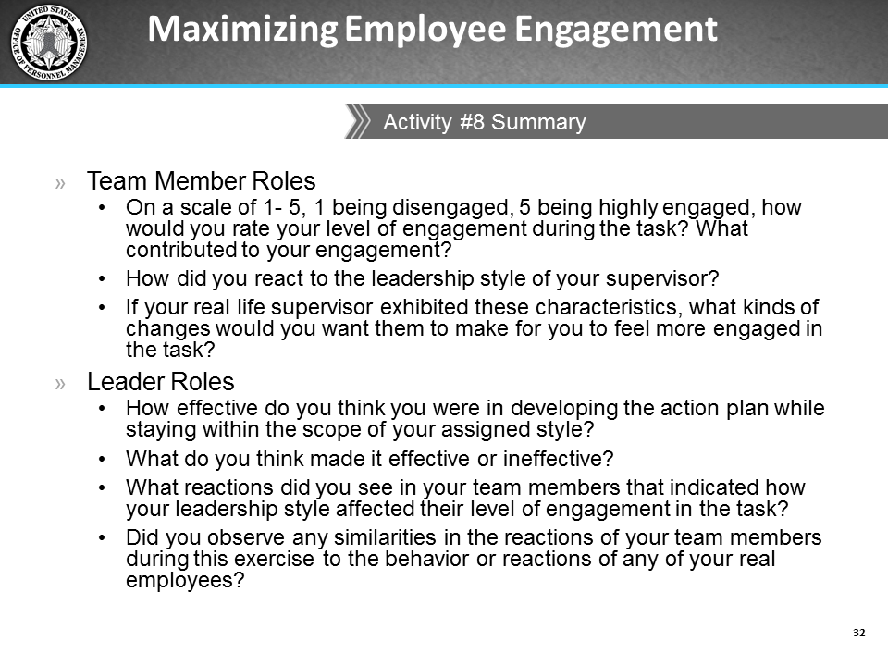
icons | Instructor Notes
Facilitate a class discussion by asking the questions on the slide.
If time permits, ask the participants how their employees’ levels of engagement would be affected by each of the leadership styles.
If there is time left, ask if any groups want to share information from their action plans. If there are no volunteers, move on to the next lesson.

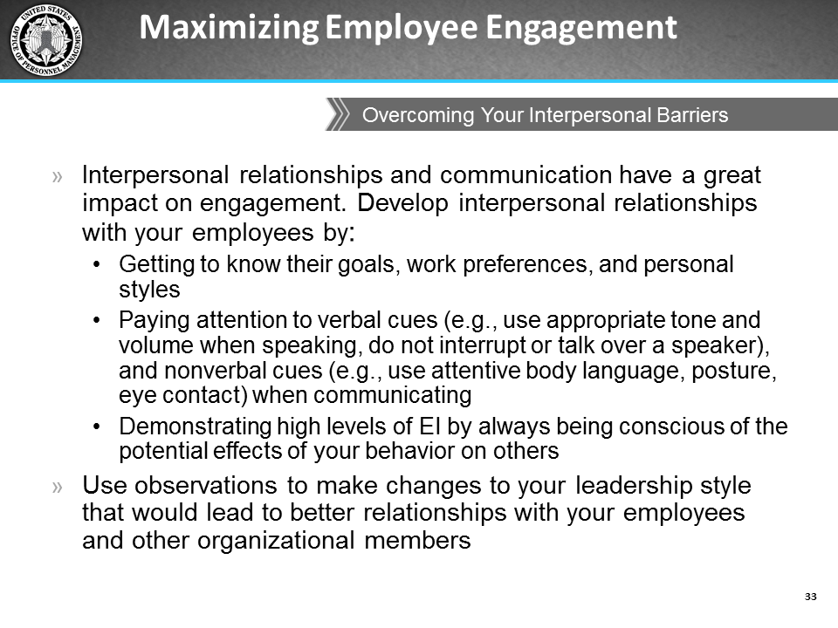
icons | Instructor Notes
Here are some things you can do to have more effective interpersonal relationships with your employees:
- Get to know their goals, work preferences, and personal styles
- Pay attention to verbal and nonverbal cues
Verbal cues might include using appropriate tone and volume when speaking and not interrupting or talking over a speaker
Some nonverbal cues are attentive body language/posture, making eye contact and using appropriate facial expressions when communicating
Demonstrate high EI by always being conscious of the potential effects of your behavior on others.
Use your observations about yourself and your staff to make changes to your leadership style that would lead to better relationships with your staff.
Remember that you can use some of what you wrote in the action plan for this activity in your personal Action Plan coming up in the next lesson.

Organizational Barriers
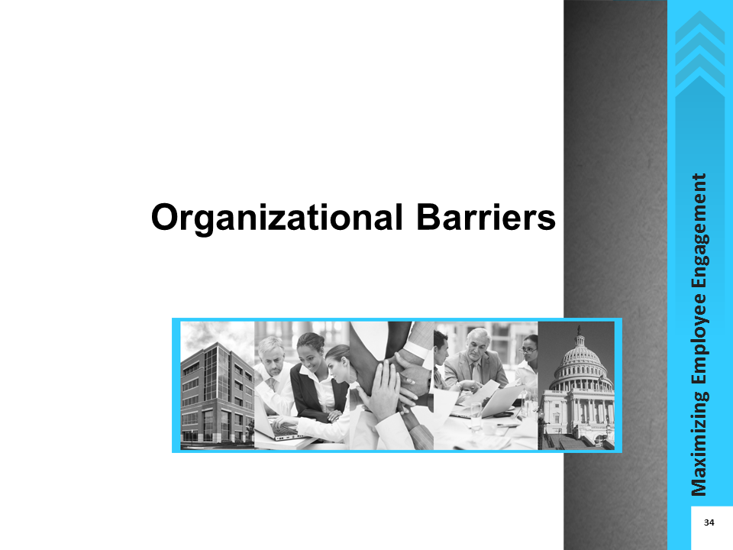
icons | Instructor Notes
 | Sometimes barriers to engagement come from the organization. Some, such as a lack of training resources, are easy to identify. Others, such as a lack of information sharing, a culture of mistrust, or poor alignment between organizational systems, can be so ingrained in an organization’s culture that it may be challenging to recognize them, to picture alternative scenarios, and think of different ways of doing work.

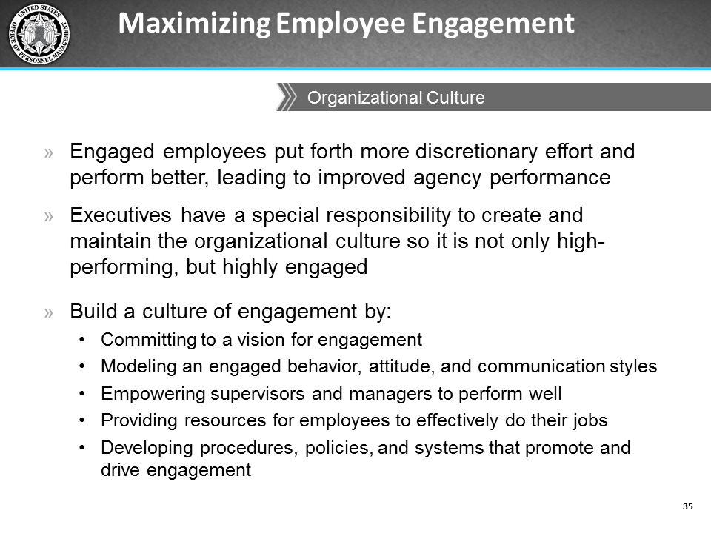
icons | Instructor Notes
Organizational culture is a strong driver of engagement. Executives have the responsibility to create and maintain a culture of engagement.
However, creating this culture does not occur in a vacuum; executives cannot simply create new engagement goals and say “From now on, we are going to do things this way,” and assume that is all that is needed to change the culture.
The process must include:
- Committing to a new vision for the agency’s engagement culture
- Supporting the desired engagement culture with decisions and actions
- Empowering managers and supervisors to take actions that complement and support the desired goals, and
- Developing or modifying agency processes and systems to drive the desired behavior.

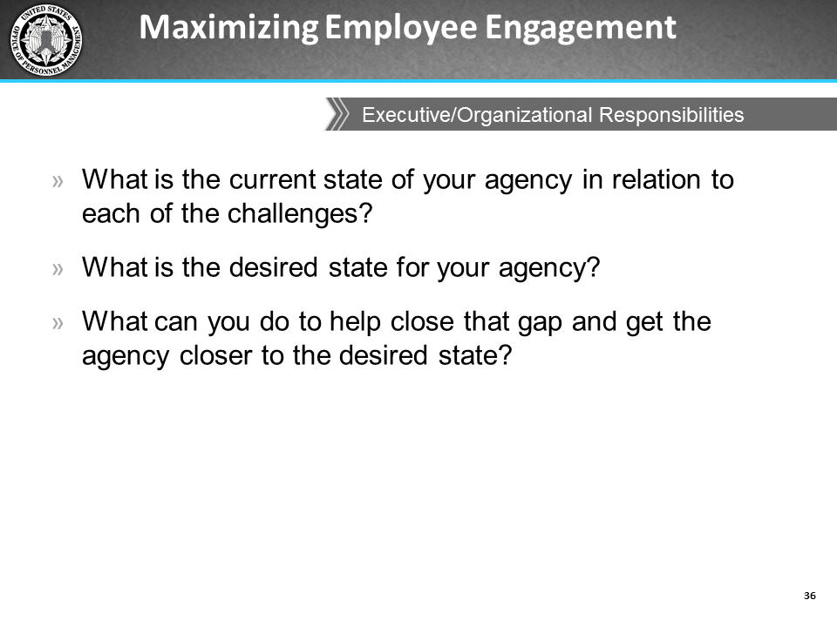
icons | Instructor Notes
 | 10 minutes
Review the flip charts containing the challenges and solutions identified during the Challenges that Influence Your Employees’ Engagement activity.
If there are no executives in the class, do the following:
- Look at 2-3 of the challenges and methods the class agreed were the organization’s or executives’ responsibilities and ask the class to reflect on the three questions on the present slide and think about how their agency might look different if their executives implemented some of those methods.
- Discuss each of the following questions with the class:
  - How would you describe the current state of your agency in relation to each of the challenges?
  - What do you think is the desired state for your agency?
  - What can you, as a supervisor or manager do, to close that gap and help get the agency closer to the desired state?
If there are executives in the class, do the following:
- Select one of the methods identified and ask for a volunteer executive to walk through the three questions with the rest of the class. [For example, have them tell the class how a suggested method (e.g., provide more rewards and recognition) would work in the agency].
- Have the volunteer executive(s) respond to each of these three questions so the rest of the class can benefit from a snapshot of how things are in the agency:
  - How would you describe the current state of your agency in relation to each of the challenges?
  - What is the desired state for your agency?
  - What can you do to close that gap and get the agency closer to the desired state? What support do you need from managers and supervisors?

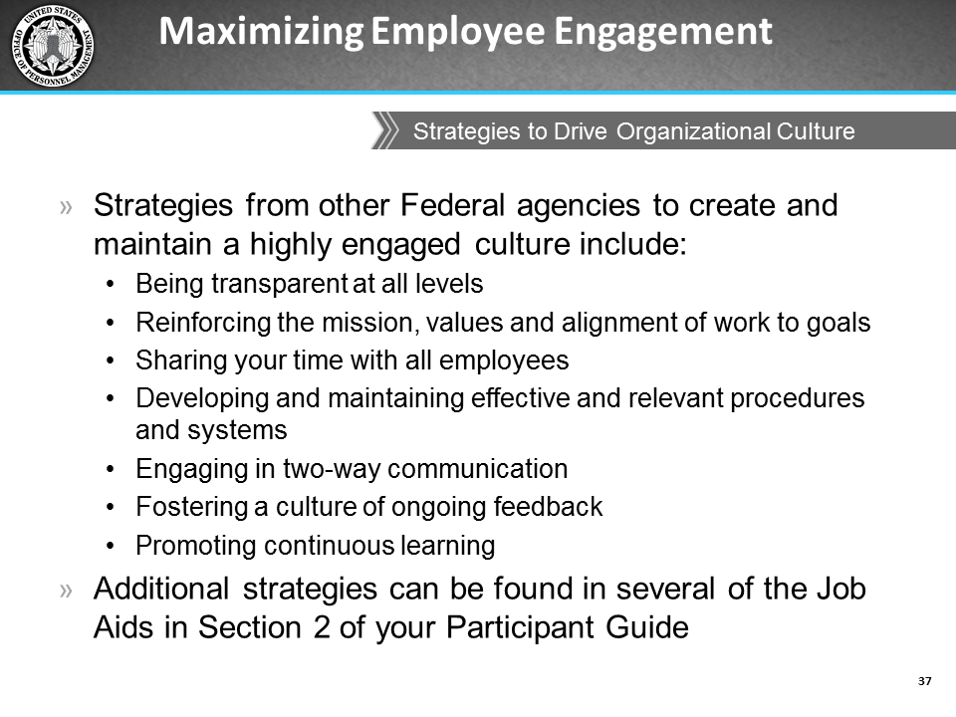
icons | Instructor Notes
 | Here are some of the activities those agencies among the Best Places to Work in 2012 use to create and maintain a highly engaged culture.
 | Read some of the strategies on the slide. Omit reading the ones that may have already been stated in the previous discussion. Here are others you can expand on:
Share your time with all employees: This shows you support and validate them and their work, and also shows you are accessible and interested in them. This can be done by simply walking around and having informal conversations with employees.
Provide agency resources, tools, and other support: An environment conducive to working can help instill a sense of pride in their workspace and the organization. It also sends the message that the organization wants to take care of them and provide for their work needs.
Foster and require a culture of ongoing feedback: Set up a cycle of regular formal progress reviews, informal interactions, and continuous learning for employees on giving, receiving, requesting, and utilizing feedback.
Additional strategies can be found in the Section 2: Job Aids in the Participant Guide:
- Other Government Agencies’ 69-73-75)
- Alternative Non-monetary Ways to Encourage Training and Development (page 75)
- Ways to Create a Culture of Engagement, which we also reviewed in Lesson 1 (page 65)

Develop an Action Plan

Lesson Overview
Topics | Estimated Time (minutes)
Action Plan | 30
Total | 30

Lesson Objectives
- Identify actions supervisors, managers, and executives can take within their sphere of influence to develop and sustain an engagement culture
- Identify actions supervisors, managers, and executives can take to overcome barriers and improve engagement within their team or department

Activity Materials and Job Aids in the IG
- Activity: Develop an Action Plan (pages 111-112)

Resources
None

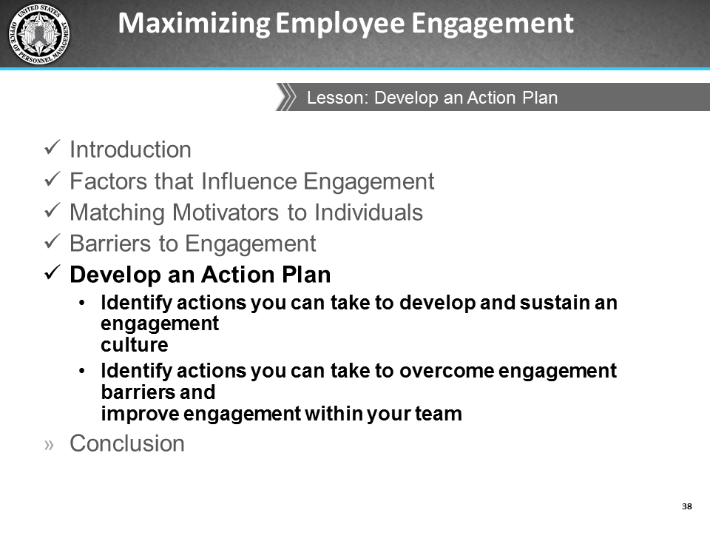
icons | Instructor Notes
 | Review the lesson objectives.
 | In the final lesson of this course, you will develop an Action Plan that details specific actions you can take to overcome barriers and improve levels of engagement among your employees. The activity in this lesson is to develop an Action Plan.

Action Plan
icons | Instructor Notes
 | You should refer to all the notes you have taken during the exercises, activities, and class discussions throughout this course to aid with creating your Action Plan.

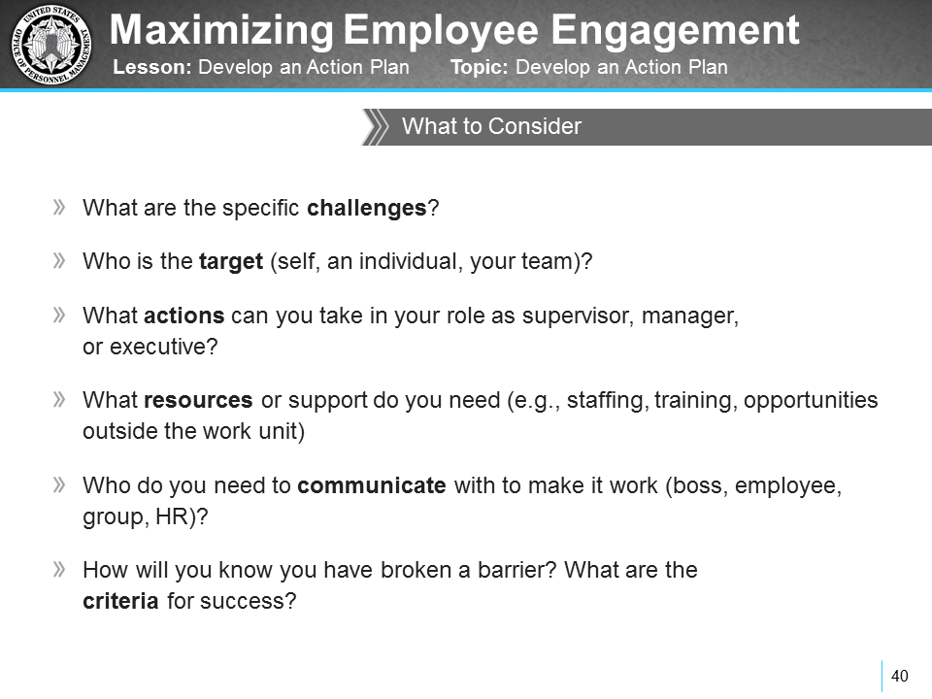
icons | Instructor Notes
 | Now you are going to use all of the information that was covered in the previous lessons to develop your action plan. As you develop this plan, you should ask yourself the six questions shown on this slide to help you determine the specific employee engagement challenges your plan will address and the strategies and tactics you will use to resolve these challenges.

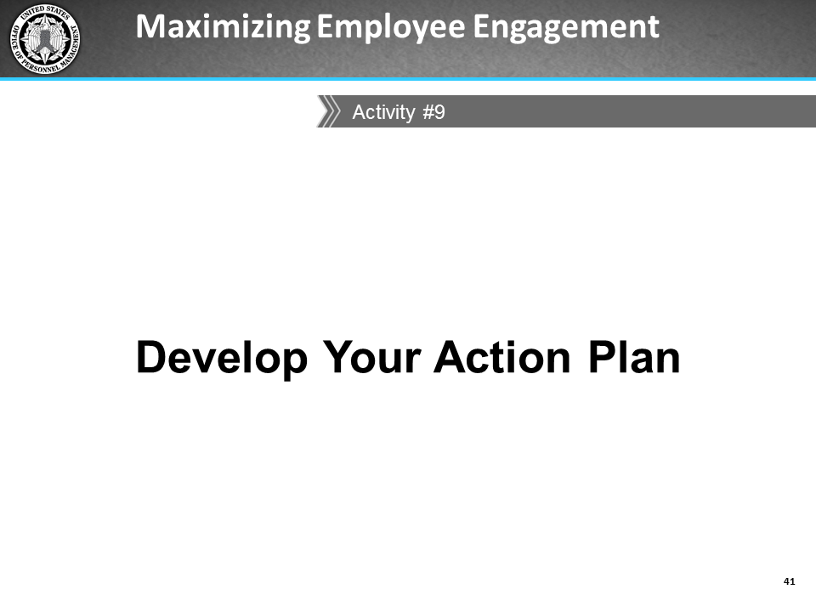
icons | Instructor Notes
 | 25 minutes
Description
Working individually, participants will develop an Action Plan to detail specific actions they will take to overcome barriers and improve levels of engagement within their sphere of influence. These can be long-term or short-term goals.
Activity Materials and Job Aids in the IG
- Activity: Action Plan (pages 111-112)
Instructions
- Ask participants to turn to the Your Action Plan activity on pages 56-57 of the PG.
- Tell them that they should think about their work environment and techniques they learned in the class to create an action plan. The plan will detail at least 3 specific challenges they have with engagement, as well as the corresponding short term and long term actions they will take to overcome these challenges to improve levels of engagement among their employees.
- Highlight some of the details on the first page of the handout, such as making sure the challenge is specific, identifying the target (self, individual, or group), actions, resources, communication plan, and noting progress toward completion.
- Remind participants to refer to the notes they have taken throughout the course to give them some ideas.
- Tell them that this is an individual activity, but if they wish to, they can share details of their action plan with other members of the class at the end of the activity so the class can provide feedback and suggestions for achieving their goals.
 | Would anyone like to share details of their action plan? Perhaps we can provide additional suggestions and ideas for achieving the goals in your action plan.
If there are volunteers: Facilitate a 10-minute discussion about the specific action plans.
If there are no volunteers:
 | Are there are any questions before we move on to the conclusion?

Conclusion

Lesson Overview
The Conclusion is approximately 5 minutes

Lesson Objectives
None

Activity Materials and Job Aids
None

Resources
- Maximizing Employee Engagement Web Based Training (WBT)
- OPM developed a 60-minute online course that provides information about engagement, the role of supervisors and managers, and some of the activities that organizations can take to create a culture of engagement. This course is hosted on OPM’s HR University (http://hru.gov) and OPM’s Training and Development Wiki (http://www.opm.gov/wiki/training/index.aspx).

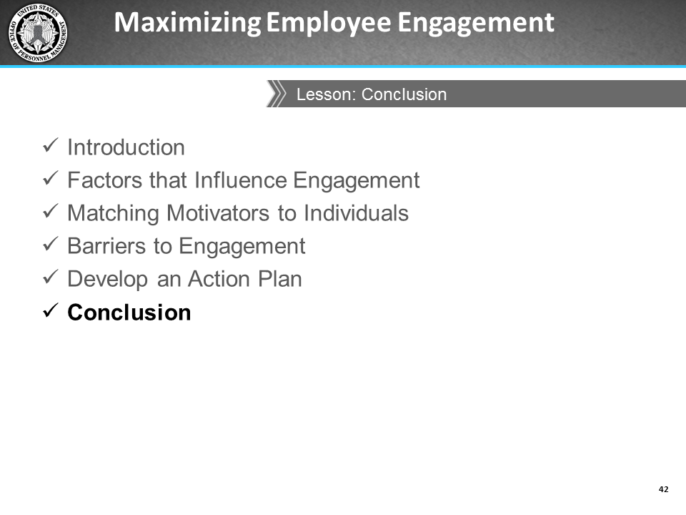
icons | Instructor Notes
 | You have now completed the Maximizing Employee Engagement course. Let’s review what you have learned.

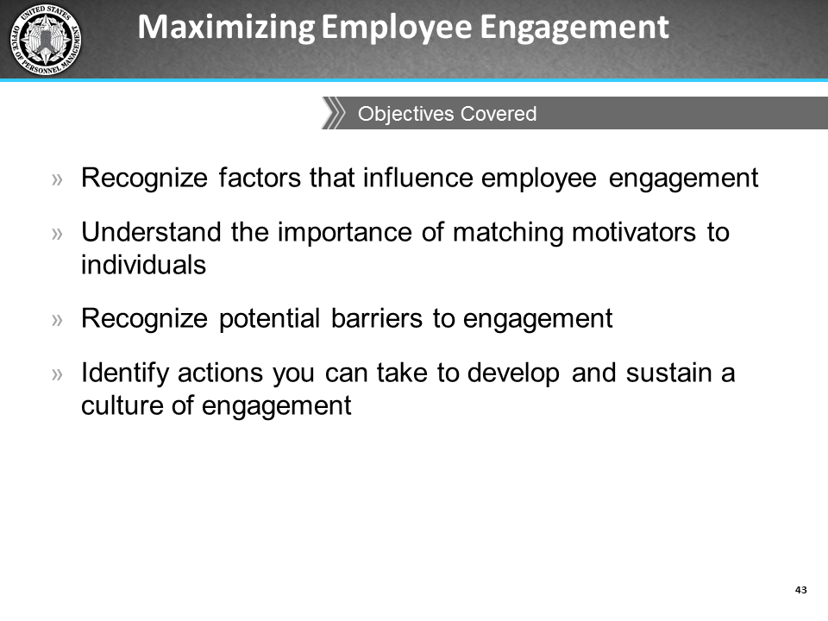
icons | Instructor Notes
We have met the following objectives:
- In lesson 1: you identified factors that influenced your own engagement as well as the engagement of your employees. You also learned about how as leaders you impact your employees’ engagement.
- In lesson 2: you learned about job design and job characteristics as motivators and the importance of matching job characteristics to different employees. We also discussed the importance of matching your leadership style to different situations which will make you a more effective leader, better able to engage your employees, and contribute positively to the organizational climate.
- In lesson 3: you identified two types of barriers to engagement: interpersonal and organizational. We identified who needs to take action to resolve those barriers and ways of addressing them.
- In lesson 4: you developed an action plan that you will take back to work and monitor and update as you accomplish each goal. You can use the Action Plan to monitor your progress on the goals you developed today, and also on those you create in the future.
Other things we covered include:
- Engagement characteristics and what being engaged means
- Myths about engagement
- Strategies from other Federal agencies in creating and maintaining a highly engaged workforce.

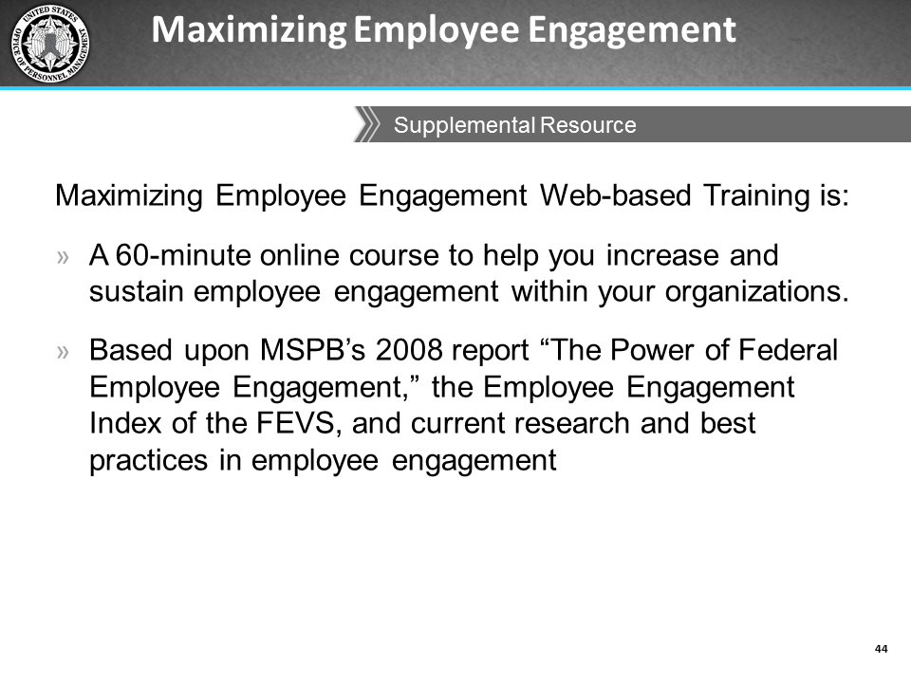
icons | Instructor Notes
If you haven’t already taken it, I encourage you to take the Maximizing Employee Engagement Web-based Training (WBT).
OPM developed this online course to help you increase and sustain employee engagement within your organizations. It is based on current research and best practices in employee engagement. It is available on OPM’s HR University (http://hru.gov) and OPM’s Training and Development Wiki (http://www.opm.gov/wiki/training/index.aspx).
 | Are there any questions before we complete the course evaluations?
 | Use this time to address any questions and comments that may still be in the Parking Lot.
I would like to thank you very much for attending this course, as well as thank you for your active participation, willingness to share, and attentiveness to the content throughout the course.
I also appreciate all the insightful discussions as well as the questions and comments. We hope this course was helpful to you personally, as well as professionally.
At this point I would like you to complete course evaluations to give us your feedback about this course. It will only take a couple minutes of your time, and would greatly help inform improvements for future training events.
Pass out the Course Evaluations and inform participants that they are free to go once they complete the Course Evaluation.
Collect the completed course evaluations.

This page left intentionally blank.

Section 2: Activities Materials

This page intentionally left blank

Activity: Factors that Influence Your Engagement
Reflect on a time when you felt engaged and/or disengaged at work. What kinds of factors in your work environment promoted or hindered your engagement?
Factors that Influence Your Engagement | Did it promote or hinder your engagement?

Activity: Challenges that Influence Your Employees’ Engagement
Think back to before you became a supervisor. What challenges did you have with your manager or supervisor that affected your engagement?
Today, as a supervisor, what are some of the specific challenges to engagement you have seen among your employees? Write these responses in the first column below.
Discuss your responses to these questions within your small group and designate a group member to be the reporter. As a class, we will help each other identify possible solutions to overcome each challenge.
Challenges that Influence Your Employees’ Engagement | Possible Solutions to the Challenges

Activity: Different Strokes for Different Folks

PART 1
Ask yourself these questions to gauge which job characteristics might best motivate your employees.
Job Characteristics | Is the employee likely to be satisfied with the…
Task Identity | Degree to which the job provides for completion of a whole and identifiable piece of work from beginning to end?
Task Significance | Difference he or she can make to others through the job?  The importance of the job compared to other jobs in the organization?
Autonomy | Level of independence and discretion allowed in making decisions about work sequence, methods, procedures, or quality control?
Skill Variety | Variety of knowledge, skills, and abilities required?
Feedback | Clarity of performance expectations (for example, quality, timeliness)?  Availability of feedback about job performance?  Frequency of performance feedback?  Access to communication channels and flows of information?

PART 2
For each job characteristic noted in the first column, describe how much authority (i.e., No authority, Minimal authority, Some authority, or Full authority) you think you have to make modifications to each of them for your employees, as well as how you would go about modifying the job characteristic to enhance engagement.
In addition to keeping in mind the individual employees you manage, also think about the nature of the work your team usually performs, human resource policies, the needs of the organization, and the imperative to be fair, objective, and transparent while you consider modifying job characteristics.
Job Characteristics | How much authority do you have to modify this characteristic? | How would you modify the job characteristic?
Task Identity
Task Significance
Autonomy
Skill Variety
Feedback

Activity: Matching your Leadership Style to the Situation

Goleman’s Six Leadership Styles
Characteristics | Coercive | Authoritative | Affiliative | Democratic | Pacesetting | Coaching
Leader’s modus operandi | Demands immediate compliance | Mobilizes people towards a vision | Creates harmony and builds emotional bonds | Forgoes consensus via participation | Sets high standards for performance | Develops people for the future
The style in a phrase | ‘Do what I tell you’ | ‘Come with me’ | ‘People come first’ | ‘What do you think?’ | ‘Do as I do, now’ | ‘Try this’
Underlying emotional Intelligence | Drive to achieve, initiative, self-control | Self-confidence, empathy, change catalyst | Empathy, building relationships, communication | Collaboration, team leadership, communication | Conscientious, drive to achieve, initiative | Developing others, empathy, self-awareness
When the style works best | In crisis; to kick start a turnaround; with problem employees | When changes require a new vision, or when a clear directive is needed | To heal rifts in a team or to motivate people during stressful circumstances | To build buy-in or consensus, or to get input from valuable employees | To get quick results from a highly motivated and competent team | To help an employee improve performance or develop long-term strengths
When the style might fail | When there is not a lot of emotional self-control | When trying to motivate more experienced experts or peers on the team | When there is avoidance of emotionally distressing situations | When there is a lot of listening and discussion but very little action | When very little guidance is given to the team on how to achieve results | When micromanaging

Activity: Matching your Leadership Style to the Situation, continued
Instructions: Below is a list of situations. For each situation, indicate which leadership style you would typically use and explain why this would be the most effective leadership style. Consider factors such as your underlying emotions, your goal in that situation, and the overall impact on the climate your style might have. Be prepared to share your responses during the follow-up discussion of this activity.
Instructor note: Answers have been prefilled in below to help you in the follow-up discussion of which style may be most effective in the situation. The responses are italicized for you to read aloud to the class if you wish.
Situation | Response
Agency leaders have formed a task force to uncover reasons for the low EVS engagement scores. They want at least one junior member from your team to be on the task force. However, none of your employees are interested in being on the task force. What leadership style do you use to assign an employee to the task force? | Coercive leadership style might be most effective in this situation. Coercive leaders give clear, direct instructions and are commanding and expect full compliance (agreement is not needed). Coercive leaders are best in times when you need unquestioned rapid action regardless of others’ interest in the situation.
You have been assigned to lead the new employee engagement task force, but were given no guidance by senior leaders on how to proceed. What leadership style do you use to get buy-in from the task force? | Authoritative leadership style might be most effective in this situation. Authoritative leaders use a “Come with me” approach where they get people moving towards a shared vision or goal. Authoritative leaders share information and empower others with knowledge. Authoritative leaders are great at motivating others to achieve an overall goal. Using this motivational and visionary style would help you get buy-in from the task force.
Your task force is made up of members who do not know, or trust each other, and some members appear to be resistant to being on the task force. What leadership style do you use to ensure the work gets done? | Affiliate leadership style might be most effective in this situation. Affiliate leaders create people connections, and help facilitate harmony within the organization. Affiliate leaders are collaborative and focus on emotional needs over work needs. This style is best used to help heal rifts and get through stressful situations, such as this situation where there appears to be tension within the team.
The task force needs to quickly deliver and present their findings about reasons for the low EVS scores to agency leaders. What leadership style do you use to assign roles to the presenters? | Pacesetting leadership style might be most effective in this situation. Pacesetting leaders set performance standards for others and exemplify those standards themselves. Pacesetting leaders often offer low guidance once the task has been assigned, expecting that others will know what to do. This style is most useful in situations when the team is motivated and competent, such as with this task force.
Your task force presented recommendations to senior leadership. Some of your team had not prepared properly and the quality of the presentation suffered. What leadership style do you use to provide your team with performance feedback after the presentation? | Coaching leadership style might be most effective in this situation. Coaching leaders emphasize the personal development of others over work-related goals. Coaching leaders are good at delegating challenging assignments and helping others discover their strengths and weaknesses and tying these to developmental actions. The members of your team who did not do as well on the presentation would benefit from you talking to them about their developmental needs in preparation and presentation skills.
As a result of the recommendations made by the committee, senior leaders have designated your work group to be part of a pilot test to try out new work procedures. You need all of your employees to buy into this plan as people are generally uncomfortable with change. What leadership style do you use to motivate your employees to participate? | Democratic leadership style might be most effective in this situation. Democratic leaders give others a voice in decision-making by encouraging and valuing their inputs. Democratic leaders help build commitment to the decision, and help others feel like they are being listened to. Having employees voice their opinions and ideas about the new work procedures can help them get over their discomfort and may motivate them to take ownership of the new procedures.

Activity: Matching your Leadership Style to the Situation, continued

Components of Emotional Intelligence
EI Component | Description
Self-awareness | - Self-confidence  - Realistic self-assessment  - Self-deprecating sense of humor  - Thirst for constructive criticism
Self-regulation | - Trustworthiness  - Integrity  - Comfort with ambiguity and change
Motivation | - A passion for the work itself and for new challenges  - Unflagging energy to improve  - Optimism in the face of failure
Empathy | - Expertise in attracting and retaining talent  - Ability to develop others  - Sensitivity to cross-cultural differences
Social Skill | - Effectiveness in leading change  - Persuasiveness  - Extensive networking  - Expertise in building and leading teams

Activity: Your Interpersonal Barriers
Take a few moments to think about some of the interpersonal barriers that exist in your interactions with your employees. Use “I” statements to write down these barriers. For example:
- I have a hard time giving negative feedback.
- I don’t communicate because I assume my employees will handle issues on their own; I don’t want to seem like a micro-manager.
When you are finished writing these “I” statements, reflect on the impact these barriers have on your communication style and list solutions to minimize these barriers.
Your Interpersonal Barriers | Solutions to Interpersonal Barriers
I …
I …
I …
I …
I …

Activity: Role Play
Instructor Notes: Separate the class into six groups of 3-4 members.
- In cases of very small class sizes (i.e., 18 or less), ensure there are at least six groups of at least two pairs of participants, where one person plays the role of the leader and the other member(s) play the role of team members.
For groups of three or more members, ask for a volunteer from each group to play the role of a leader, while the rest of the group members play the roles of team members.
Ask for a volunteer from each group to play the role of the leader for this exercise. The rest of the group members will be team members. Once leaders have been assigned in each group, give the assigned leader one of the Leadership Style cards to act out.
Instruct the leader not to allow their group members to see the leadership style they have been given. Remind them that they must behave according to the leader type they receive throughout the duration of the role play exercise. Answer any questions they may have, and then begin the role play exercise.

Scenario
Your organization has just received the results from the Federal Employee Viewpoint Survey.
The scores were captured at both the department and organizational level, and your department-level scores reveal that engagement in relation to supervisors and intrinsic work experience is low. The results show:
- Lack of support for their individual development from their supervisors
- Supervisors do not listens to what employees have to say
- Supervisors do not encourage employees to come up with new and better ways of doing things
- Managers do not communicate the goals and priorities of the organization to employees
Senior leaders have asked supervisors and managers to work with their employees on how to overcome these challenges.
They requested action plans from each department by the end of next month.

Task
The group must develop two to three actions to improve engagement in the department based on the scenario described above. The leader must stay in character the entire time, and document their plan in the Action Plan table on the second page of their activity form.

Role Play Action Plan
Based on the results from the EVS, develop a list of 2-3 actions to improve engagement in your department.
Specific Challenges | Proposed Action | Due Date | Resources (e.g., money, staff) | Communication (who should know)
I …
I …
I …

Reflection Activity
Thinking about your employees, how do you think interacting with them with your usual leadership style might be affecting their engagement with you, other team members, and the organization?

This page left intentionally blank

Leadership Styles
Print the leadership styles and cut to create the Leadership Style Cards to be used in this activity

Coercive Leader
- Demonstrates higher concern for the task (developing an action plan) and lower concern for group members
- Displays a tough-minded, no-nonsense attitude
- Soothes fears and gives clear directions by his or her powerful stance
- Makes final decisions and limits group members' inputs
- Demands immediate compliance (agreement is not needed)
- Takes conflict head-on by pushing own agenda through
- Needs emotional self-control for success
- Can seem cold and distant

Affiliative Leader
- Demonstrates lower concern for the task (developing an action plan) and higher concern for group members
- Pays close attention to group members' comfort and needs
- Focuses on supporting and collaborating with others rather than initiating action/starting work
- Soothes others feelings when conflict arises; always wants to have harmony
- Supports others' decisions instead of providing or pushing own input and thoughts
- This style is often done badly when it avoids emotionally distressing situations

This page left intentionally blank

Pacesetting Leader
- Builds challenge and exciting goals for group members
- Expects excellence and often exemplifying it themselves
- Has very high standards for performance
- Very conscientious about own and others' work
- Sets the pace for performance, which may be very aggressive and may not take into consideration the rest of the group's feelings about the pace
- Quickly tries to get to the bottom of causes for the conflict (e.g., identify poor performers and demand more of them) so the pace can continue
- Usually offers low guidance, expecting group members to know what to do
- This style is often done badly when it lacks emotional intelligence, specifically self-management

Coaching Leader
- Connects group members wants to organizational goals (e.g., development of action plan)
- Shows concern for helping group members improve performance and develop long-term strengths
- Good at delegating challenging assignments because of faith in the individual, which often leads to high levels of loyalty
- Is very self-aware of own and others' feelings and shows empathy
- Coaches individual employees to develop personally and professionally
- Often engages in long conversations that reach beyond the workplace
- This style is often done badly when it looks too much like micromanaging

This page left intentionally blank

Authoritative Leader
- Demonstrates both high concern for the task (developing an action plan) as well as for group members
- Mobilizes group members towards a vision, telling them where to go but not how to get there
- Demonstrates self-confidence and empathy for others
- Acts as a catalyst for bringing about change
- Attempts to balance group members' concerns while emphasizing work requirements
- Openly shares information, hence giving knowledge power to others
- This style is often done badly when trying to motivate more experienced experts or peers on the team

Democratic Leader
- Demonstrates high concern for group members and the task (i.e., developing an action plan)
- Emphasizes teamwork, collaboration, and participation by stimulating group members
- Listens for and seeks out different ideas, opinions, and attitudes which may be different from own
- Displays open-mindedness
- Focused on building buy-in or consensus on ideas
- This style is often done badly when it looks like lots of listening but very little effective action

This page left intentionally blank

Activity: Develop Your Action Plan
For this final activity you will indicate specific actions you will take to overcome engagement barriers and improve levels of engagement among your employees. Think about the level of engagement you want to achieve for yourself and your team in the near term (i.e., 6 months to a year) and long-term (i.e., within 1 to 2 years). You will identify at least 3 specific engagement challenges and develop a plan of action for each. The challenges do not have to be listed in order of priority. Refer to the notes you have taken throughout this course to give you some ideas, such as factors that keep you engaged, the results of your assessment of your primary management style, things that you identified as organizational barriers, strategies from other government agencies, as well as any other notes from the rest of the slides and other activities. You will document this in the table on the next page of this exercise.
Account for the following factors when developing a comprehensive action plan:
- Specific challenge related to engagement
- Target (self, individual, or group)
- Actions you can take within your role as a supervisor or manager
- Resources you will need (e.g., staffing, training, opportunity outside work unit)
- Communication plan - who to talk with to make this work (boss, employee, group, HR/HCM)
- Completion - you must be prudent in following up with your action plan and marking off successes
After identifying at least 3 specific challenges and actions you are going to take to address them, you may share some of the details of your Action Plans—within your comfort level—with the rest of the class. The class will provide feedback and suggestions for addressing the challenges.

Your Action Plan
Challenge | Target | Action to be Taken | Due Date | Resources (e.g., money, staff) | Communication (who should know) | Completed (yes/no)

Section 3: Job Aids
This page left intentionally blank.

Job Aid: Debunking Myths about Employee Engagement
Myth | Reality
Compensation is the biggest driver of employee engagement | - Compensation is important, but not a main driver of employee engagement.  - A sense of purpose about why the agency exists and its contribution to society is a bigger driver for employees than compensation.  - A sense of participation with the agency (e.g., recognition and rewards, opportunities to grow, and involvement) is a bigger driver for employees than compensation.
The drivers of engagement are the same across agencies | - Drivers of employee engagement across various organizations are more different than they are similar, even if they are within the same industry.  - Each agency's culture differs and drivers at your agency may not be drivers at another because of the differences in organizational culture, work focus, and types of employees.
Employee engagement is hosting an event every now and then | - Effective employee engagement should be in everything the agency does; it must be integrated and embedded into the agency’s strategic planning, HR and talent management planning, organizational culture and values, and so on.
The best agency leaders are all great at inspiring employees | - The best agency leaders might not necessarily be viewed as the most inspirational leaders. However, they have the capability to ensure employees have the right resources and tools to perform their jobs consistently and get the best results (e.g., engagement, performance, retention) from their employees.
Employee engagement is HR’s responsibility | - HR's role is to help managers maximize engagement with their teams by providing tools, resources, and talking points that enable managers to have meaningful conversations with their employees.  - Employee engagement happens on every level, must be owned by everyone in the organization, and must start at the top and filter through the agency.  - Employee engagement defines the success (or downfall) of an entire company. An engaged workforce is a major factor in achieving agency goals.  - Paying (more) attention to engagement is time well spent, even for the busiest executive, manager, and supervisor.

Job Aid: Ways to Create a Culture of Engagement
The following are quick actions and the ways to execute those actions to help create a culture of engagement in your organization.
Action | How to Create a Culture of Engagement
Instill a sense of pride in the work or workplace | - Use the performance management process to communicate to employees how their work contributes to achieving agency objectives. Performance meetings provide an opportunity to establish an alignment between the employee's role and the agency mission and goals.  - Encourage employees to take ownership of their work.
Create a sense of trust and transparency with leadership | - Communicate a clear vision of how the agency will accomplish its mission.  - Communicate honestly about the organization and ensure your words are consistent with your actions.  - Ensure there is transparency between decisions and the strategic direction of the organization.
Provide the opportunity to perform well at work | - Provide frequent informal or formal performance feedback and discussions.  - Hold employees accountable for results through a structured performance management process.  - Ensure that employees' job responsibilities make good use of their competencies and that they are provided with the resources, time, and assistance needed to perform their jobs.
Provide reward and recognition consistently and frequently | - Take time to validate and acknowledge employee achievements.  - Integrate rewards and recognition into how employees are managed on a day-to-day basis.
Provide opportunities for personal and professional growth | - Demonstrate an interest in developing and mentoring employees.  - Help employees assess, fine-tune, and develop new skills.  - Give employees specific goals as well as the training, tools, and resources for employees to perform their job.  - Use a competency-based approach to ensure their skills are well-used and continually enhanced.
Create a positive work environment that also focuses on teamwork | - Create opportunities for team members to interact and work together.  - Actively solicit feedback and satisfaction and incorporate their thoughts and ideas into the agency operation.

Job Aid: Fast Track to Lowering Engagement
The following are some of the quickest ways to lower engagement amongst your employees.
- Failing to provide transparent and trustworthy senior leadership.
- Failing to communicate openly, frequently, and effectively with employees about organizational challenges, as well as organizational achievements.
- Failure to have open two-way communication with the workforce, to include communicating with employees as a group and on an individual basis.
- Failing to include and solicit feedback from employees in developing strategies and recommendations for agency improvements.
- Failing to have senior leaders take an active interest in EVS results and develop agency-wide and office plans for improvements.
- Failing to empower employees to be innovative and find ways to better perform their jobs.
- Failing to provide the right tools and resources for employees to effectively do their jobs.
- Failing to communicate a clear vision of the agency's mission and helping employees see line-of-sight between their work and the agency's mission.
- Failing to provide opportunities for career advancement and provide greater responsibilities or new experiences.
- Failing to recognize and acknowledge good work.
- Failing to appropriately reward or promote employees.
- Failing to include employee engagement as a performance metric in managers' performance plans.
- Failing to incorporate team problem-solving and decision-making, especially where it affects them.
- Failing to tailor engagement efforts to the culture/climate of your agency.

Job Aid: Other Government Agencies’ Strategies to Drive an Engaged Organizational Culture

Introduction
The following government agencies shared with OPM what they do to maximize employee engagement within their organizations:
- Department of Education (ED)
- Department of Human Services (DHS)
- National Aeronautics and Space Administration (NASA)
- National Institutes of Health (NIH)
- Nuclear Regulatory Commission (NRC)
- Office of Management and Budget (OMB)
- Office of Personnel Management (OPM)
- United States Coast Guard (USCG)
While not all of these will work within your agency because of the different organizational culture (e.g., mission, union), you should still be able to find a few ideas that will be well-suited and relatively easy to adopt and practice within your team. Implementing these or similar ideas could have a positive influence on your agency's engagement levels, and ultimately, FEVS engagement scores.

Employees
Ideas involving Employees | What it looks like
Create a “Morale Committee” | Create a committee that develops and enacts ideas to make staff feel appreciated (e.g., promoting health and wellness activities, providing non-monetary rewards).
Recognize Other Staff | Encourage staff to nominate coworkers for good work. Employees select who wins the awards, which promotes a sense of pride by being nominated by their peers.
Practice the Servant Leadership Model | Focus on helping others and modeling good leadership.
Get Together Outside Work | Schedule activities such as bowling and movies to help bring teams together.

Supervisors and Managers
Activities Supervisors and Managers can do | What it looks like
Create Teambuilding Activities | Many offices hold division level retreats and seminars that include all divisional staff. These meetings typically focus on topics of interest to the division and often include segments that are used to identify ways to improve the operation of the organization.
Bring Food into the Equation | Supervisors or managers bring in food (e.g., pizza, cupcakes) for employees during group meetings. Managers take their staff out for lunch just because they want to; staff can see that the manager enjoys doing it and that it is authentic and not forced.
Develop and Monitor Individual Development Plans (IDPs) | As part of the performance process, employees and their supervisors discuss their IDPs. This includes discussing goals, performance expectations, and things they will do throughout the year.
Give Employees the Opportunity to Select their Own Assignments | Encourage employees to express interest in and volunteer to work on specific projects.
Encourage and Model Work-life Balance | Managers model this by not always staying late or always working on weekends. They also publicly support work-life programs such as telework, Employee Assistance Program (EAP), or health and fitness programs, as appropriate.
Create Lateral and Rotational Assignments | Staff is frequently assigned collateral duties on teams, working groups, and steering committees that allow the individual to work on tasks that are outside their routine. These assignments are helpful in instilling ownership, inclusion, and a sense of collaboration for the staff and their respective offices.
Take Opportunities to Provide Positive Feedback | Give positive reinforcement and feedback.

Executives’ Actions
Actions Executives can take | What it looks like
Set up Monthly Focus Groups to have “Diversity Dialogues” | Focus on dialogues about age, race, gender, disability, etc. for employees to become more knowledgeable about differences and similarities in behaviors, communication styles, values, etc., as well as become more comfortable with different types of employees.
Encourage Leaders to be More Visible and Accessible | Walk around the office, be seen, and make eye contact. Demonstrate the organization’s values and competent, approachable, and personable leadership. Have a monthly “Coffee with an Executive” or “Lunch with an Executive” that offers an opportunity for participants to discuss a list of current questions/issues.
Develop an “Idea Factory” to Solicit Ideas from Employees | Set up an automated system to actively solicit ideas about ways to improve organizational challenges from employees, where one employee can build on what another suggests. Some agencies recognize employees who have provided ideas by having senior leaders introduce them during town halls and ask them to describe their ideas to everyone. Senior leaders sign on to act as champions for the ideas, which helps break down communication and accessibility barriers between leaders and employees.
Provide Guidance on Effective Performance Management Systems | Assist leaders and employees to learn more about how to make the most of the performance management process. One agency developed a booklet that presents role plays and frequently asked questions that can help both the employee and the supervisor get into the mode for performance appraisal and discussion about developmental opportunities. Agency-sponsored workshops for supervisors or managers also provide an opportunity for them to learn how to recognize and reward employees.
Create a Monthly Newsletter | Solicit input from employees about both official and personal events (e.g., voluntary efforts or commemorative events) to include in a newsletter.
Host Quarterly/Yearly Town Halls | Use town halls and all-hands meetings to keep employees informed and to obtain input from them.

Executives’ Strategies
Strategies for Executives | What it looks like
Advertise and Promote the Mission and Values of the Organization | Create unrehearsed videos in which employees state what the organizational values mean to them. Display quotes on a banner at the entrance of the building along with the mission and values of the organization.
Create a Clear and Open Communication Strategy | Hold staff meetings soon after senior staff meetings. This helps control flow of information rather than contributing to rumors, and establishes consistent and open communication.
Practice Situational Leadership Approach | Have the most knowledgeable person about an issue in the room present to others, rather than have the most senior person do it.
Develop an “Innovation Lab” | Hold sessions used to tackle organizational issues, emphasizing innovation and creating energy among employees. Other departments are invited to join, and any employee can be a facilitator.
Create a “Solicitations of Interest” System | Set up an internal system where supervisors who need extra staff can ask for it. Half-page announcements are emailed to employees weekly so they can see what work is coming up and apply for it. Employees can apply directly for the work; they do not need to go to HR for a formal assignment. Assignment length may range from a couple of months to six months. They can also be part time, such as two hours a week for two months.
Encourage Employees to Develop Action Plans to Respond to FEVS Results | Form Advisory Teams of employees to determine how to address the areas identified by survey results as needing improvement. Employees develop action plans for specific areas; they collect information/data and assist in the implementation of the response. Senior leaders keep employees updated on progress (via agency-wide conference calls, town halls, newsletters, emails, etc.).
Emphasize Continuous Learning | Leadership supports a proactive, assertive, leaning forward attitude and provides continual training and development to employees, through formal training, developmental assignments, details, and lateral assignments to new positions.
Encourage Managers to Get Together and “Talk” | Supervisors and managers meet with each other, and then meet with managers at the level above them on a monthly basis to discuss topics of interest. Any relevant information from these meetings is then fed back to the staff to increase the sharing of information.
Encourage Honest Conversations Between Supervisors and Employees | Encourage honest conversations about what the supervisor can do to make the employee want to contribute his or her best talent. Honesty can increase feeling of trustworthiness and make employees feel that their supervisor has their best interest at heart and will not use information shared in confidence against them.

Job Aid: Alternative Non-monetary Ways to Encourage Training and Development

Encourage inquiry and a sense of constant curiosity
- Encourage a seminar series that provides opportunities for employees to give presentations about their various areas of expertise to other employees.
- Collaborate with other managers to act as panel experts for discussions or presentations and lend knowledge to panel discussions on various topics. Invite employees to these forums, allowing them to ask questions and gain new knowledge.
- Encourage employees to spend time interviewing other employees or managers in other sectors about their work. Dedicate a specific number of hours each quarter to allow your employees to conduct these informational interviews.

Encourage service and volunteerism
- Encourage employees to volunteer within their communities to further develop their particular skill sets, and also develop leadership skills by taking on leadership roles within their communities.

Encourage inter-departmental learning
- Promote resources already available in the organization by inviting employees who have a variety of skill sets or belong to other offices to collaborate and work on projects together.
- Organize informal interdepartmental get-togethers during lunch, breaks, or brown bag sessions to discuss, build relationships, and build communities of practice.

Encourage Employees to find a mentor
- Talk to your employees to find out which of them are interested in mentoring or even job shadowing. Then think about who would make good matches to provide both parties with developmental opportunities.
- Be a facilitator in helping employees form relationships with other individuals, such as supervisors, managers, or executives you have access to.
- Use mentoring to get older and younger employees talking, such as sharing knowledge and ideas and combining perspectives in new and interesting ways.

This page left intentionally blank

Section 4: Supplemental Readings and References

This page left intentionally blank

Suggested Additional Reading
Albrecht, S. L (Ed.). (2010). Handbook of employee engagement: Perspectives, issues, research and practice. Northampton, MA: Edward Elgar Publishing, Inc.
Ayers, K. (n.d.) The high cost of a lack of engagement. Retrieved Dec 3, 2012, from http://www.engagementisnotenough.com/pdfs/Cost_of_Engagement.pdf
Bakker, A., & Leiter, M. (2010) Work engagement: A handbook of essential theory and research. New York, NY: Psychology Press.
Carbonarra, S. (2013). Manager’s guide to employee engagement. New York, NY: McGraw Hill.
Catlette, B., & Hadden, R. (2912, Aug 17). How to foster outrageously awesome employee engagement. Fast Company. Retrieved from http://www.fastcompany.com/3000474/how-foster-outrageously-awesome-employee-engagement
Cook, S. (2008). The essential guide to employee engagement. London, UK: Kogan Page.
Employee Engagement Report. (2011). BlessingWhite North America. http://www.blessingwhite.com/%5Ccontent%5Creports%5C2008EmployeeEngagementNAOverview.pdf
Employee Engagement Report. (2011). BlessingWhite North America. Retrieved from http://www.blessingwhite.com/content/reports/blessingwhite_2011_ee_report.pdf
Haudan, J. (2008). The art of engagement: Bridging the gap between people and possibilities. New York, NY: McGraw Hill.
Kahn, W. A. (1990). Psychological conditions of personal engagement and disengagement at work. Academy of Management Journal, 33(4): 692-724.
Kruse, K. (2012). Employee engagement 2.0: How to motivate your team for high performance. Richboro, PA: The Kruse Group.
Macey, W., Schneider, B., Barbera, K., & Young, S. (2009). Employee engagement: Tools for analysis, practice, and competitive advantage. Chichester, UK: Wiley Blackwell.
MacLeod, D., & Brady, C. (2008). The extra mile. London, UK: FT Prentice Hall.
Vance, R.J. (n.d.) Employee Engagement and Commitment: A guide to understanding, measuring and increasing engagement in your organization. SHRM Foundation: Alexandria, VA. Retrieved from http://www.shrm.org/about/foundation/products/Pages/EmployeeEngagement.aspx

References
Albrecht, S. L (Ed.). (2010). Handbook of employee engagement: Perspectives, issues, research and practice. Northampton, MA: Edward Elgar Publishing, Inc.
Attridge, M. (2009). Employee work engagement: Best practices for employers. Research Works: Partnership for Mental Health. 1, 1-12.
Bakker, A., & Leiter, M. (Eds.) (2010). Work engagement: A handbook of essential theory and research. New York, NY: Psychology Press.
Bassi, L. (2012, May 3). Debunking employee engagement myths. Retrieved from http://www.astd.org/Publications/Blogs/Learning-Executive-Blog/2012/05/Bassi-6-Debunking-Engagement
Blake, R. R., & Mouton, J. S. (1964). The managerial grid. Houston, TX: Gulf Publishing Company.
Branham, L. (2001). Keeping the people who keep you in business. Soundview Executive Book Summaries, 22(1). Retrieved from http://www.abp-corporation.com/abpportal/biblioteca/ExecSummaries-Keeping_the_People.pdf
Branham, L. (2005). The 7 hidden reasons employees leave: How to recognize the subtle signs and act before it's too late. New York, NY: AMACOM Books.
Campion, M., & Thayer, P. (1987). Job design: Approaches, outcomes, and trade-offs. Organizational Dynamics, 15, 66‑79.
Carbonarra, S. (2013). Manager’s guide to employee engagement. New York: McGraw Hill.
Classle. (n.d.) Interpersonal barriers in communication. Retrieved from https://www.classle.net/content-page/interpersonal-barriers-communication#
Cook, S. (2008). The essential guide to employee engagement. London: Kogan Page.
Employee Performance Management Workgroup (2011, Nov). Goals-Engagement-Accountability-Results: Getting in GEAR for Employee Performance Management. Report to the National Council on Federal Labor-Management Relations
Employee Engagement Focus Groups and Interviews. (2013, Jan 30). [Interview]. Chris McLaren, Office of Management and Budget, Washington, DC.
Employee Engagement Focus Groups and Interviews. (2013, Feb 14). [Interview]. Christine Heflin, Department of Commerce, Washington, DC.
Employee Engagement Focus Groups and Interviews. (2012, Dec 5). [Focus group]. Representatives of OPM, Nuclear Regulatory Commission, US Coast Guard, and Department of Energy. Office of Personnel Management, Washington, DC.
Garlick, R. (2007). Managing your boss: The impact of manager personality and style on employee performance. Hospitality.Net. Retrieved Jan 8, 2013 from http://www.hospitalitynet.org/news/4032781.html
Goleman, D. (2000). Leadership that gets results. Harvard Business Review, 78(2), 78-90.
Goleman, D. (1998). What makes a leader? Harvard Business Review, 76(6), 93-102.
Goleman, D., Boyatzis, R., & McKee, A. (2001). Primal leadership: The hidden driver of great performance. Harvard Business Review, 79(11), 42-51.
Haudan, J. (2008). The art of engagement: Bridging the gap between people and possibilities. New York: McGraw Hill.
Kahn, W. A. (1990). Psychological conditions of personal engagement and disengagement at work. Academy of Management Journal, 33(4), 692-724.
Lindner, J. R. (1998). Understanding employee motivation. Extension Journal, 36 (3). Retrieved from http://www.joe.org/joe/1998june/rb3.php
Macey, W., Schneider, B., Barbera, K., & Young, S. (2009) Employee engagement: Tools for analysis, practice, and competitive advantage. Chichester: Wiley Blackwell.
MacLeod, D., & Brady, C. (2008). The extra mile. London: FT Prentice Hall.
Miller, J. (2012, Dec 14). Highest ranked agencies distinguished by strong leadership. Retrieved from http://www.federalnewsradio.com/204/3156902/Highest-ranked-agencies-distinguished-by-strong-leadership
Northouse, P.G. (2007). Leadership theory and practice. Thousand Oaks, CA: Sage Publications, Inc.
O’Connell, M. (2012, Dec 13). ‘Best Place to Work?’ —Not so much. Retrieved from http://www.federalnewsradio.com/204/3155352/Best-Place-to-Work----Not-so-much
Seshadri, S. (2010, July 7). Six myths of employee engagement. Retrieved from http://www.executiveboard.com/blogs/six-myths-of-employee-engagement/
Suharti, L., & Suliyanto, D. (2012, Sep). The effects of organizational culture and leadership style toward employee engagement and their impacts towards employee loyalty. World Review of Business Research, 2(5), 128-130.
U.S. Merit Systems Protection Board. (2012, Dec). Federal employee engagement: The motivating potential of job characteristics and rewards. http://www.mspb.gov/netsearch/viewdocs.aspx?docnumber=780015&version=782964
U.S. Merit Systems Protection Board. (2008, Sep). The power of Federal employee engagement. Retrieved from http://www.mspb.gov/netsearch/viewdocs.aspx?docnumber=379024&version=379721
U.S. Merit Systems Protection Board, (2009, July). Managing for engagement—Communication, connection, and courage. Retrieved from http://www.mspb.gov/netsearch/viewdocs.aspx?docnumber=437591&version=438697&application=ACROBAT

Section 5: Optional Activities with Accompanying PowerPoint Slides

This page left intentionally blank

Optional Activity: Lesson 1 Vignettes (Slides and Instructions)
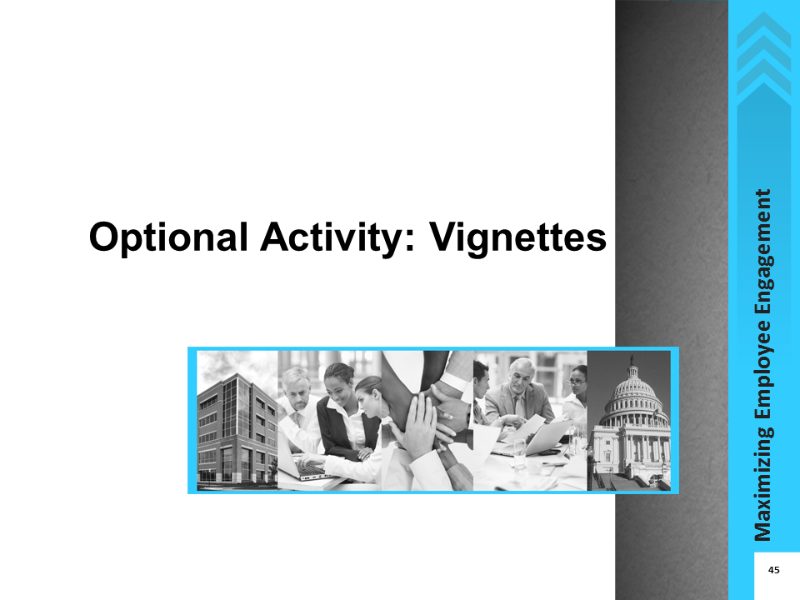
icons | Instructor Notes
 | You may use this optional activity to supplement the learning in Lesson 1, Factors that Influence Engagement, when discussing participants’ own level of engagement (i.e., “Your Engagement” topic).
 | 25 minutes
Description
In small groups, participants will read vignettes about fictitious supervisors and how the engagement levels of these supervisors impacted the engagement levels of their employees. They will then answer the corresponding questions to the vignette within their groups, and present their responses to the rest of the class. You will help the class identify cause and effect between the engagement levels of supervisors and the engagement levels of the supervisors’ employees as well as the engagement levels of others around them.
Resources
- Flip chart and marker
- Lesson 1: Participant Guide Optional Activity Package
Activity Materials and Job Aid in the IG
- Activity: Vignettes (pages 129-131)

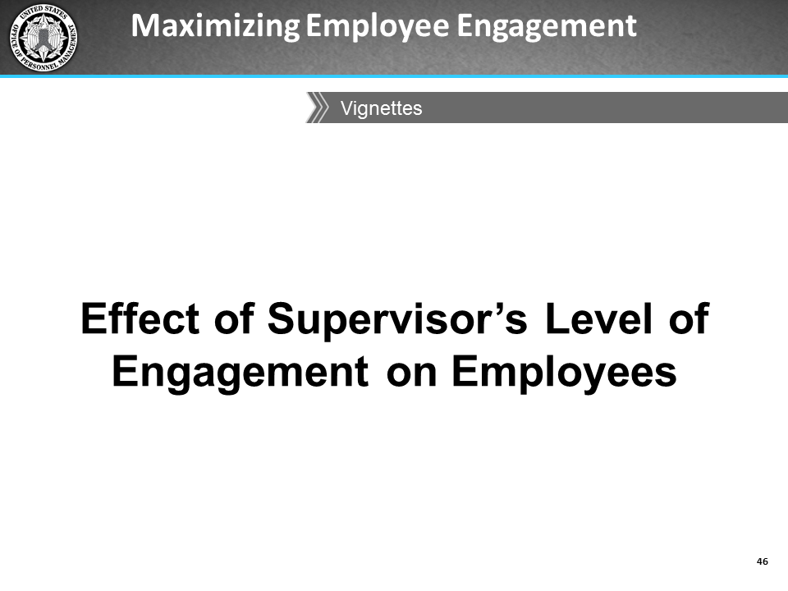
icons | Instructions
- Divide the class into 3 groups
- Distribute the Lesson 1: Optional Activity package to the participants.
- Assign a vignette to each group.
- Instruct participants to read their assigned vignettes and answer the questions in the handout with their group.
- Tell them that they will report their proposed solutions to the rest of the class and discuss why they believe their solutions would work.
Have each group briefly give a synopsis of their vignette. Then each group will read the assigned questions and answers.
Ask other groups if they agree or disagree with each group’s proposed solutions, and why. Ask them for additional solutions.
Encourage discussion about times when participants experienced similar situations and how they dealt with them.
As illustrated by these vignettes and the class discussion, you can see why knowing about and being able to identify the different factors that affect engagement will help you be able to understand different motivators for your employees.
Remember the Action Plan you will be completing at the end of the course. Reading about the supervisors in these vignettes, who may have the same kinds of supervisor style or engagement challenges with their employees as you should provide ideas of how impactful you are to your employees as well as ideas of how to address engagement challenges with your employees.

Lesson 1 Optional Activity Materials

Vignette 1
Betty is a manager who loves her job and is very passionate about what she does and how she does it. She takes advantage of opportunities to learn more about her field, attending an annual conference and signing up for seminars when they are offered. Her personal values align well with those of the agency, and she emphasizes the importance of their mission to her staff. She ensures that her people are prepared to take advantage of developmental opportunities. Her staff always knows her expectations for their work because she meets with them regularly to discuss their work.
Her employees always give her their best and follow her lead in looking for opportunities to grow professionally. They take great pains with their work to ensure it’s the best they can do. They often collaborate with each other, reaching out to help each other achieve their goals.
Betty has never thought to nominate her team for the agency’s annual Outstanding Department of the Year award for exceptional performance, even though managers often tell her how much they enjoy working with her team. They often praise the team’s professionalism and say that the team’s work is first-rate. Betty takes great pride in receiving these compliments, as she believes it is because of the high standards she has instilled in the team.

Questions for discussion:
- On a scale of 1- 5, 1 being disengaged, 5 being highly engaged, how engaged do you think Betty is? What is the basis for your judgment?
- Betty is clearly very involved in her own work and expects her team to meet her high standards. What are some of the positive results of Betty's level of engagement in her job?
- How would your employees respond to Betty's style and level of engagement? Why?

Vignette 2
Sam was promoted to supervisor almost a year ago, partly because of his strong technical skills, but also because he so clearly loved what he was doing. His values closely matched the mission of the organization, which made him work harder than many of his counterparts. He is highly competent in his team’s technical area, and often prefers to solve problems himself rather than delegating appropriately to his employees or ask their opinions on how to proceed.
Although Sam is courteous and respectful to his staff, he does not spend much time talking with them to find out about their career goals or professional interests. He is very reserved and his team seems to be reluctant to initiate conversations with him about topics such as his expectations for their performance, opportunities for growth, or offering to take more responsibility for decision making.
Sam received feedback during his performance review that suggested he should focus on his interpersonal skills as a way to help his staff become more engaged with their work and the agency. Since he received this feedback, Sam has become less enthusiastic and involved in his work. He often leaves work early and avoids having one-on-one conversations with his team. He knows that this is having a negative effect on his team’s engagement and motivation, but he does not know what to do.

Questions for discussion:
- Sam was highly engaged at the time of his promotion, but the elements of his job that require supervision and one-on-one interaction with staff make him uncomfortable. As a result he is becoming less engaged. What effect will this have on his team's level of engagement?
- If you were Sam's manager and you noticed this change in behavior, what would you do?
- If Sam really wants to change things and get his team engaged in their work, what could he do?

Vignette 3
Francine is an experienced supervisor who absolutely loves her job. She enjoys both the technical work and, particularly, being in a position to assist and influence others in their career development. She feels that working with her team is one of the most important things she does, and looks forward to opportunities to mentor them and share her knowledge. Francine also acts as a conduit for information from other parts of the organization. Last month, her manager told her that several budget-cutting actions were coming within the next two months. These included cutting training classes and cuts in awards programs for the rest of the fiscal year. Depending on how much money is saved through these cuts, leadership is considering reorganizing some departments to improve efficiency.
Her staff seemed to appreciate her interest and they came to her for advice and, following her example, they worked very collaboratively. After she told her team about the upcoming budget cutting measures, she has noticed that they seem to be working more on their own rather than seeking out others to share ideas or discuss problems. In addition, they are not communicating with her in person, often choosing to email her rather than call or come to her office. So far, performance has not decreased, but Francine is concerned that the cuts are causing her team to feel less engaged with the agency.

Questions for discussion:
- What are some potential causes for the change within the team?
- What can Francine do to help improve the team’s engagement level?
- What effect might her staff’s lower levels of engagement have on Francine’s own attitude and engagement? What could she do to re-energize herself?

This page left intentionally blank

Optional Activity: Lesson 3 Case Study (Slides and Instructions)
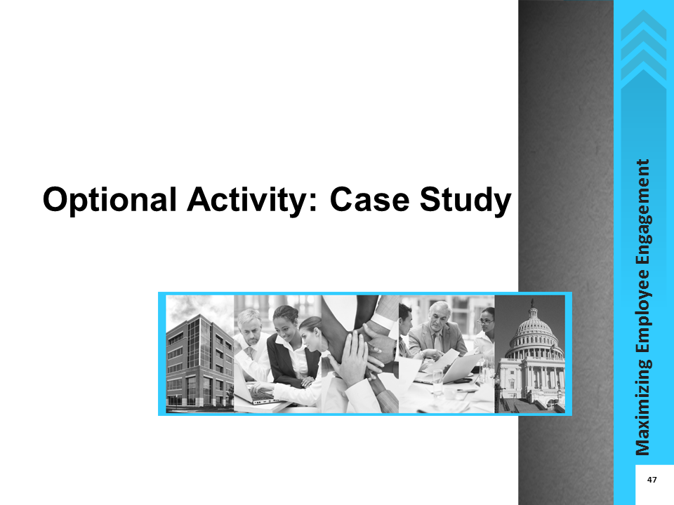
icons | Instructor Notes
 | You may use this optional activity to supplement the learning in Lesson 3, Barriers to Engagement, when discussing Organizational Barriers. However, you will need to swap this for the Role Play activity which is part of the topic on Interpersonal Barriers. This Case Study and the Role Play require the same amount of time to complete and discuss.
 | 20 minutes
Description
Working in small groups, participants will read the case study and discuss the questions at the end of the case study. They must identify factors that hinder and support employee engagement at the fictitious organization, and provide recommendations for what a leader could do to increase engagement. There will be a report-out of the activity, as well as a class discussion about the case study.
Resources
- Flip chart and marker
- Lesson 3: Participant Guide Optional Activity Package
Activity Materials and Job Aids in the IG
- Activity: Case Study (pages 136-137)
- Job Aid: Other Government Agencies' Strategies to Drive an Engaged Organizational Culture (pages 111-115)
- Job Aid: Alternative Non-monetary Ways to Encourage Training and Development (page 116)

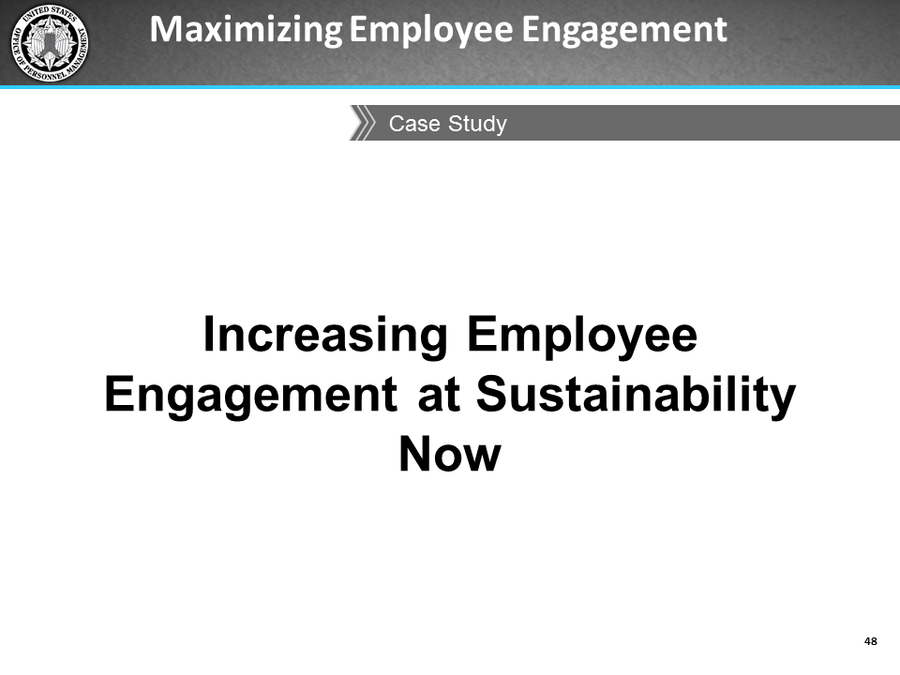
icons | Instructions
- Divide the class into 3 groups.
- Distribute the Lesson 3: Optional Activity Participant materials to the participants.
- Instruct the groups to read the case study and then discuss the questions at the end of the case study as a group.
- Tell participants to identify one member of their group who will report the groups' responses to the class during the follow-up discussion of the activity.
Tell participants they will have 10 minutes to read the case study and discuss their responses to the questions within their groups.
 | Have the reporter from each group list their recommendations and explain why they made those recommendations. Chart their responses on the flip chart for the class to see.
Ask the participants to identify some organizational barriers in their own agencies and lead them into a discussion about what they can do to overcome these barriers.
Share a few strategies some Federal agencies have used to overcome barriers to employee engagement and refer participants to the following two job aids in Section 2 of the Participant Guide:
- Other Government Agencies’ Strategies to Drive an Engaged Organizational Culture (pages 72-76),
- Alternative Non-Monetary Ways to Encourage Training and Development (page 77).
 | Let’s talk about 2-3 of these strategies. For example, let’s look at the first strategy for executives noted in your job aid “Other Government Agencies’ Strategies to Drive an Engaged Organizational Culture.” How would you implement the “Set up Monthly Focus Groups to have ‘Diversity dialogues’” recommendation in your agency?
 | Encourage them to incorporate some of these strategies while trying to increase employee engagement at the organizational level.

Lesson 3 Optional Activity Materials - Case Study

Sustaining Employee Engagement through Change
You are a supervisor at the non-profit think tank Sustainability Now (SN), whose goal is to advance research in the field of environmental sustainability. SN has been among the most highly respected organizations in its field. In the three decades of its existence, it has played a major role in changing the way government agencies, corporations, and individuals interact with their environment.
However, over the past five years, things have been changing at SN. While employees typically had very long tenures, now several people at all levels have left after just a few years. The recession resulted in reduced funding for research, and recently two new think tanks have cropped up in the same field, vying for scarce resources. Mid-level researchers are working long hours trying to win as many grants as they can from a smaller pool. Ratings on morale and supervision, as measured by the organization’s annual climate survey, have dropped considerably.
Recent exit interviews indicate frustration with bureaucracy. “The Executive Team approves every single grant application. It often takes up to a month to get permission to apply,” said one scientist who called it quits after seven years. “By the time we start working, it’s a scramble, and there isn’t enough time to develop an outstanding application.”
Talk at the cubicles is about who worked the longest over the weekend and whether there will finally be funds to hire someone to help relieve some of the workload. Water cooler conversations are dissolving into complaints that the annual bonus—the same amount for all employees—does not reward individual performance. Junior employees have a different complaint: that their supervisors are more interested in working on their own research than in ensuring that their employees get opportunities to apply their skills. You recently overheard one of your employees tell another, “I would love to take on a bigger role and lessen some of my boss’s workload—she is always stressed out. But she keeps putting off meetings I try to schedule to discuss my research interests or development. Those might help her see that I could help her directly. It just doesn’t seem important to her at all.”
On the other hand, benefits, especially the ability to telework and work flextime got high ratings from employees at all levels and tenures. Other human resource processes are well managed too. The internship and training program for entry-level scientists both get a lot of positive feedback and have applicants lining up for the entry-level jobs. But more than anything, it is the work itself that seems to be sustaining a lot of people in these turbulent times. “I love the research I do,” enthuses one employee. “It makes me feel I’m giving back to the environment, and that’s the most important thing for me.” This passion continues to show in the work that Sustainability Now does: last year, two senior researchers received national awards for their contribution to the field.

Questions for group discussion:
- What kinds of issues are going on at Sustainability Now that appear to be hindering employee engagement?
- What factors appear to support employee engagement?
- What types of factors are playing out among different groups of employees?
- As a supervisor at Sustainability Now, what actions would you take to improve employee engagement?

This page left intentionally blank.

Course Evaluation

This page left intentionally blank

Maximizing Employee Engagement Instructor-led Training Course Evaluation
I am: | Supervisor | Manager | Executive
Please indicate your impressions of the items listed below.
Statement | Strongly Agree | Agree | Neutral | Disagree | Strongly Disagree
1. The course met my expectations.
2. I will be able to apply the knowledge learned about employee engagement.
3. The learning objectives for each topic were identified and followed.
4. The content was organized and easy to follow.
5. The materials in the Participant Guide were pertinent and useful.
6. The Facilitator was knowledgeable.
7. The quality of facilitation was good.
8. The Facilitator met the course objectives.
9. Class participation and interaction were encouraged and plentiful.
10. Adequate time was provided for questions and discussion.

How do you rate the course overall?
Excellent Good Average Poor Very poor
General Comments
Thank you for your participation!

Source: U.S. Merit Systems Protection Board. (2012, Nov). Federal employee engagement: The motivating potential of job characteristics and rewards.
Source: Goleman, D. (2000). Leadership that gets results. Harvard Business Review, 78(2), 78-90.
Goleman, D. (2000). Leadership that gets results. Harvard Business Review, 78(2), 78-90.
Source: Bassi, L. (2012, May 3). Debunking employee engagement myths. Retrieved from http://www.astd.org/Publications/Blogs/Learning-Executive-Blog/2012/05/Bassi-6-Debunking-Engagement/ Seshadri, S. (2010, July 7). Six myths of employee engagement. Retrieved from http://www.executiveboard.com/blogs/six-myths-of-employee-engagement/
Source: Miller, J. (2012, Dec 14). Highest ranked agencies distinguished by strong leadership. Retrieved from http://www.federalnewsradio.com/204/3156902/Highest-ranked-agencies-distinguished-by-strong-leadership O’Connell, M. (2012, Dec 13). ‘Best Place to Work?’ —Not so much. Retrieved from http://www.federalnewsradio.com/204/3155352/Best-Place-to-Work----Not-so-much Employee Engagement Focus Groups and Interviews. (2012, Dec 5). [Focus group]. Office of Personnel Management, Washington, DC.
Source: Coro Fellows Program in Public Affairs. (2013 Mar 22). With GSA Canceling Trainings, How Can Feds Develop New Skills? Retrieved from http://www.govexec.com/excellence/promising-practices/2013/03/gsa-canceling-trainings-how-can-feds-develop-new-skills/62004/#.UVBNyU6CY0Y.email

